## OPENDJ Installation

Download setup from <https://github.com/OpenIdentityPlatform/OpenDJ>

Run the .msi file and install it in D:/PTC/OpenDJ

Once done open Command Prompt as Administrator and go to OpenDJ directory run the setup.bat

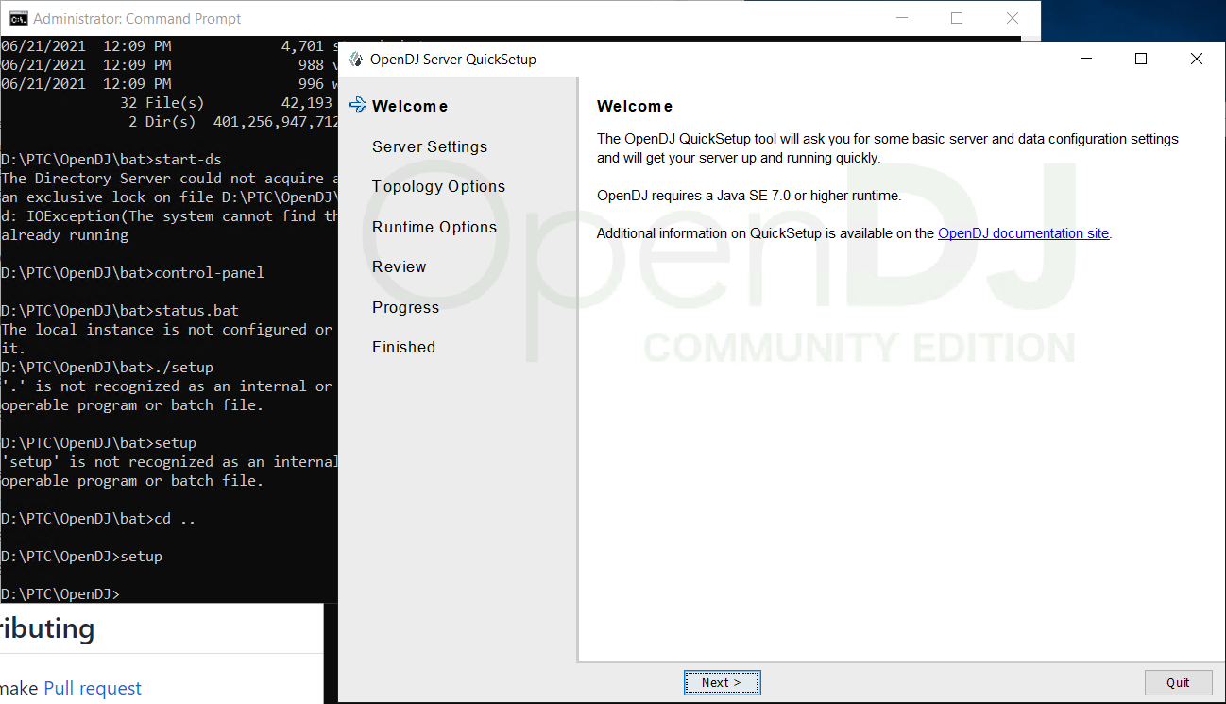

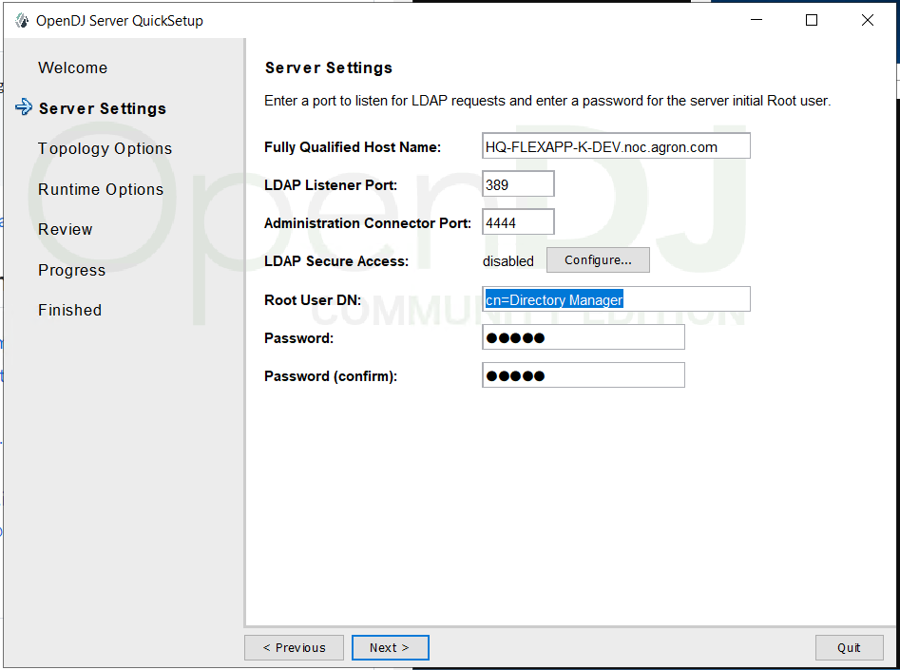

Password : admin

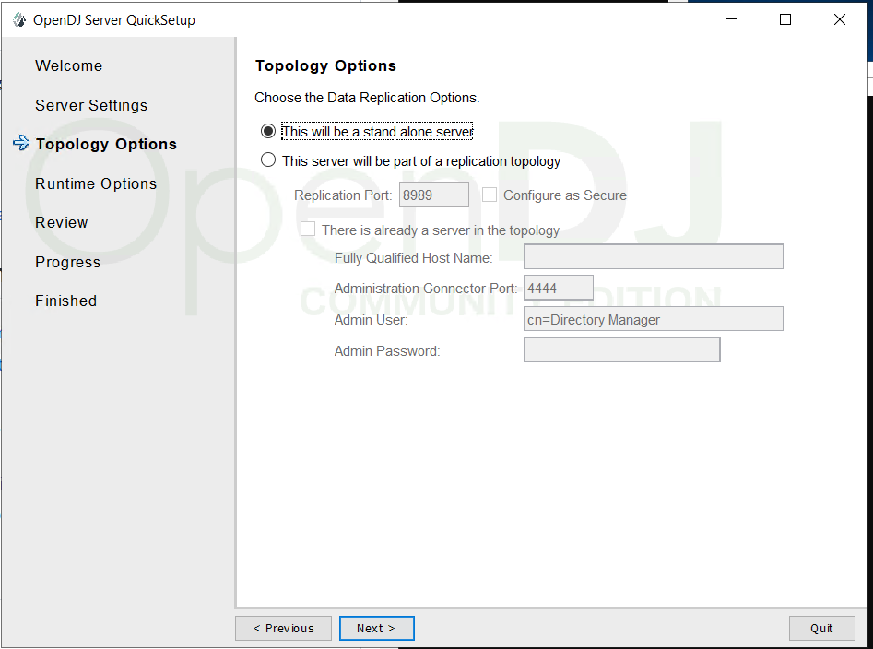

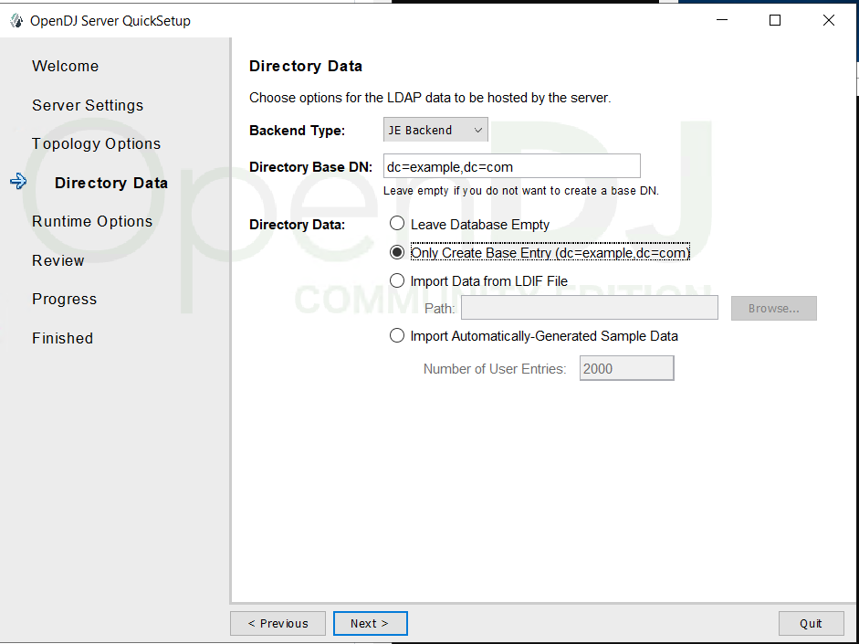

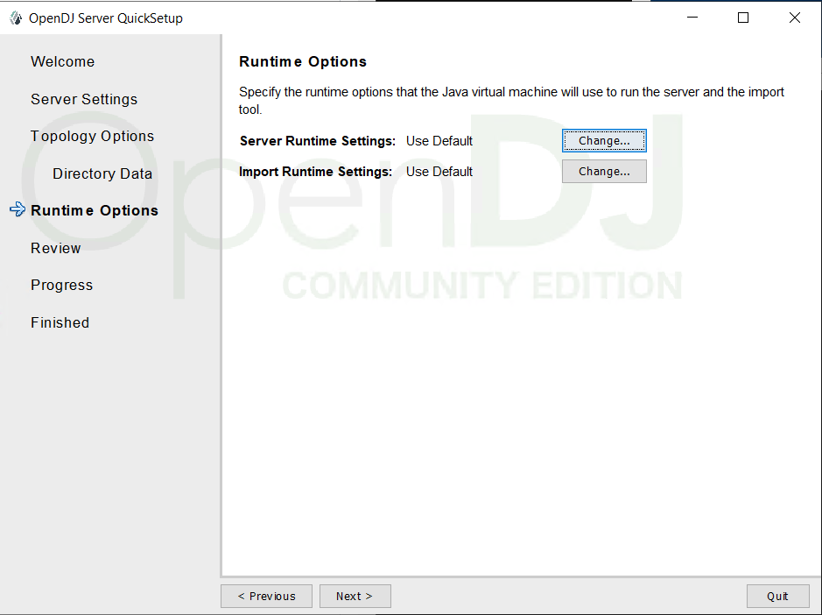

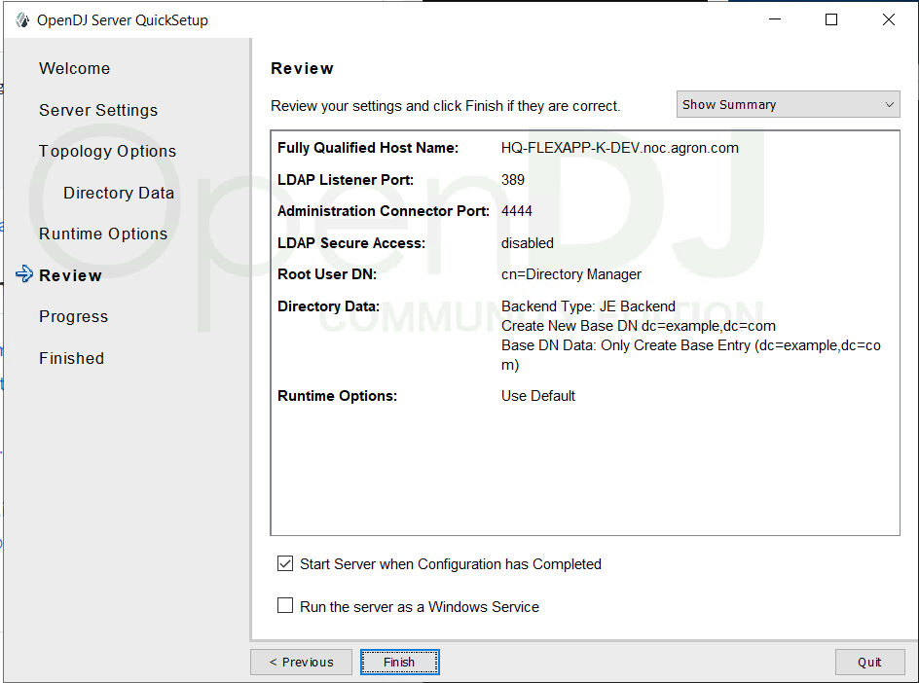

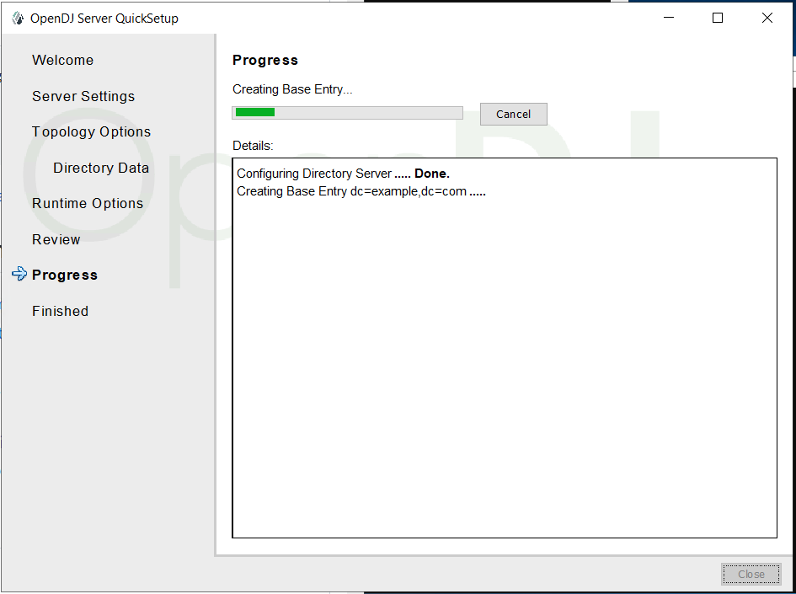

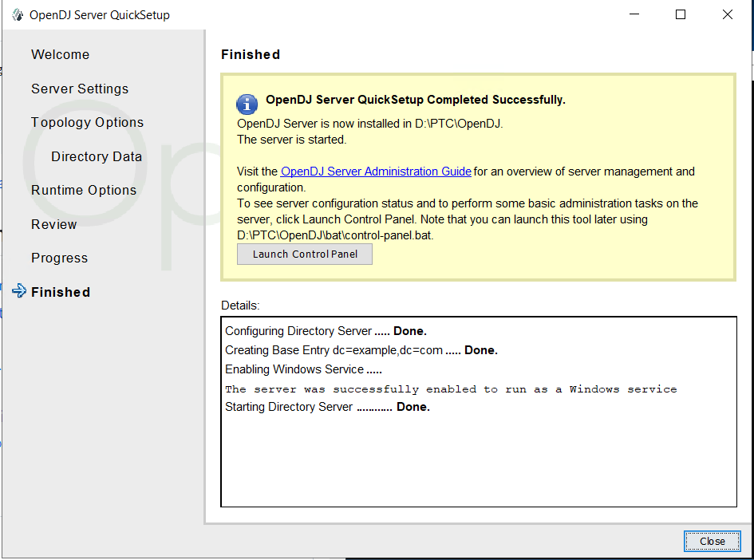

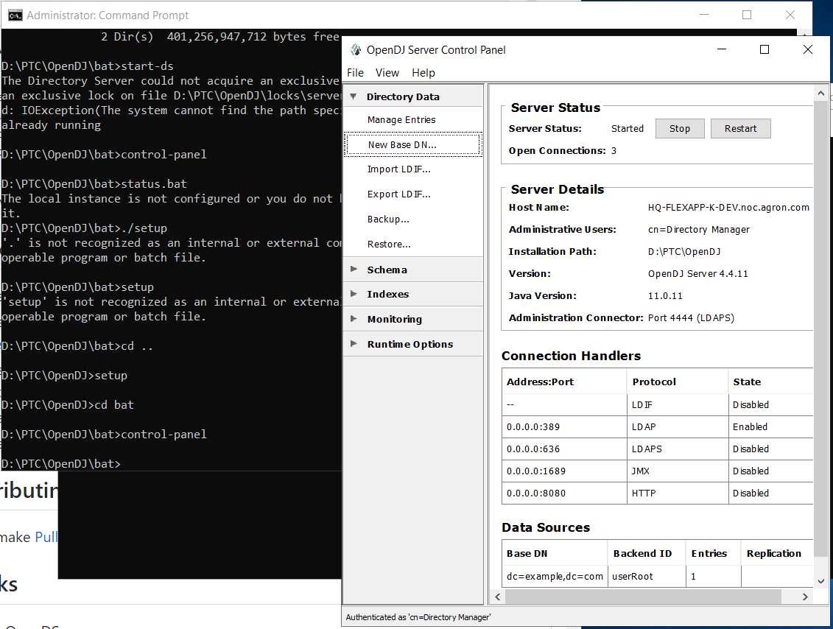

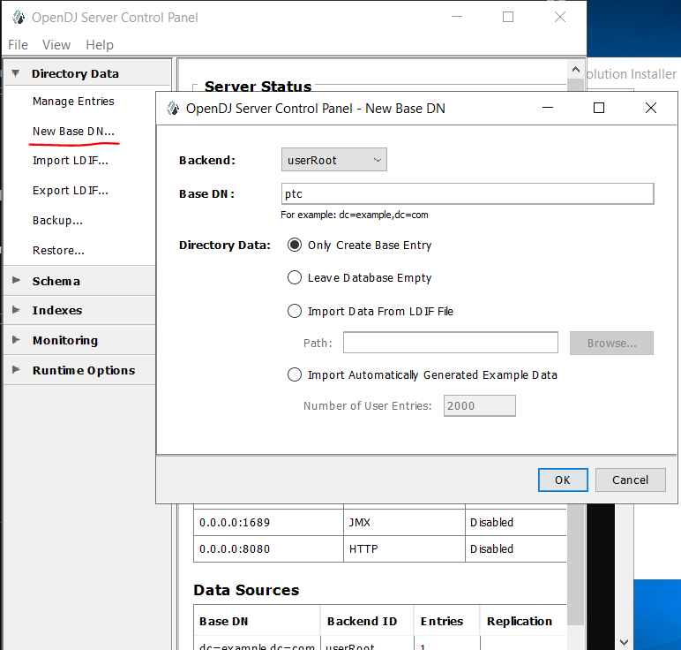

No need to create anything in OpenDJ as we are going to use WindchillDS 11.2 till upgrade completes

## WindchillDS 11.2 Installation

Download Windchill 11.2 PTC Solution Installer and CD for WindchillDS

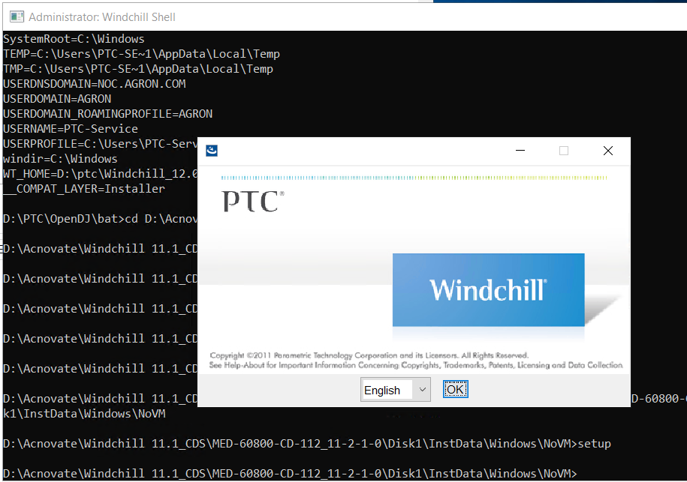

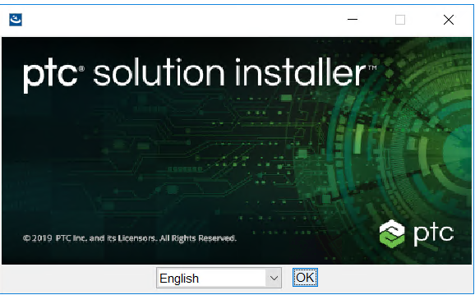

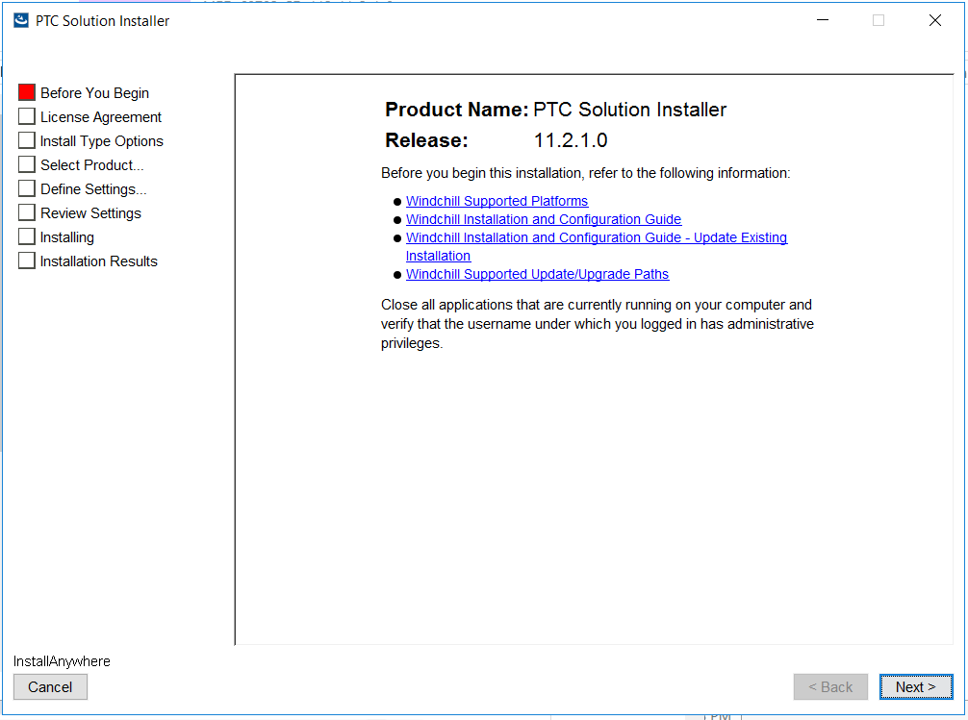

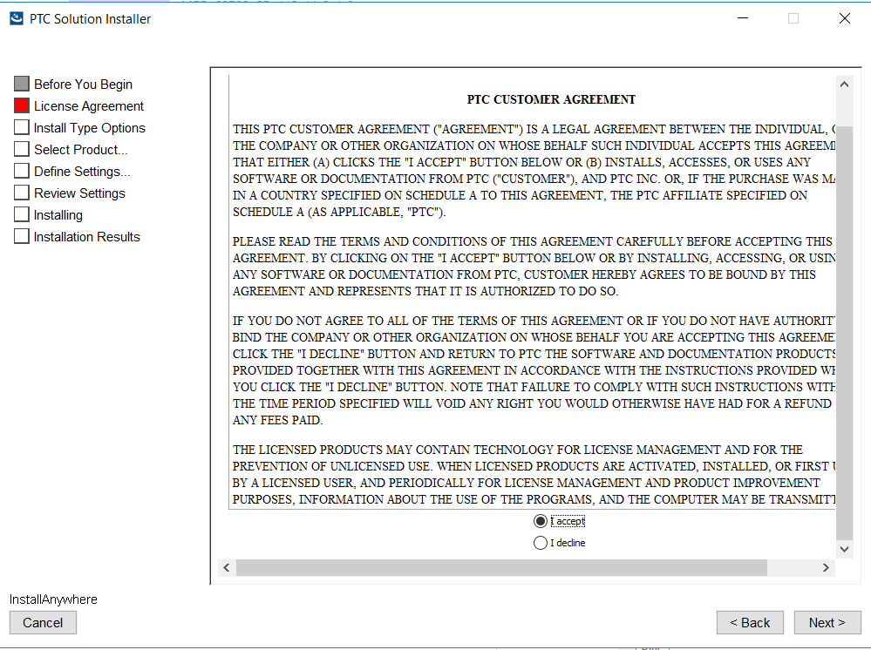

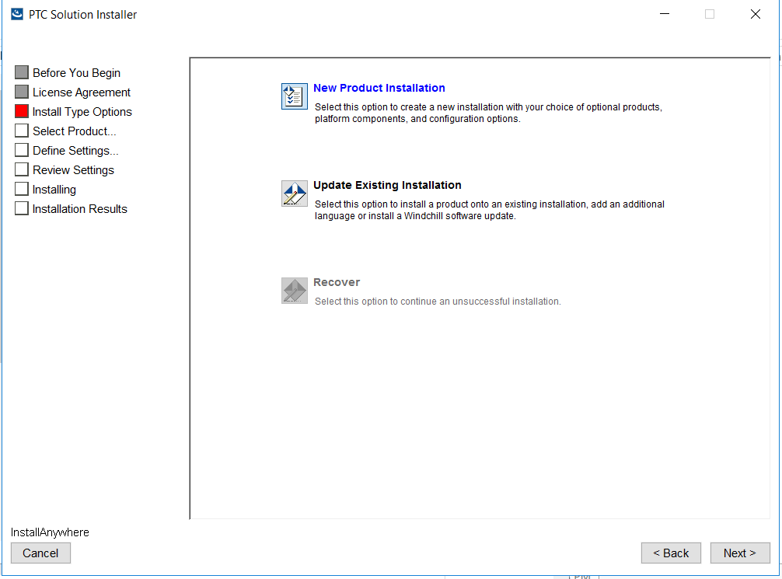

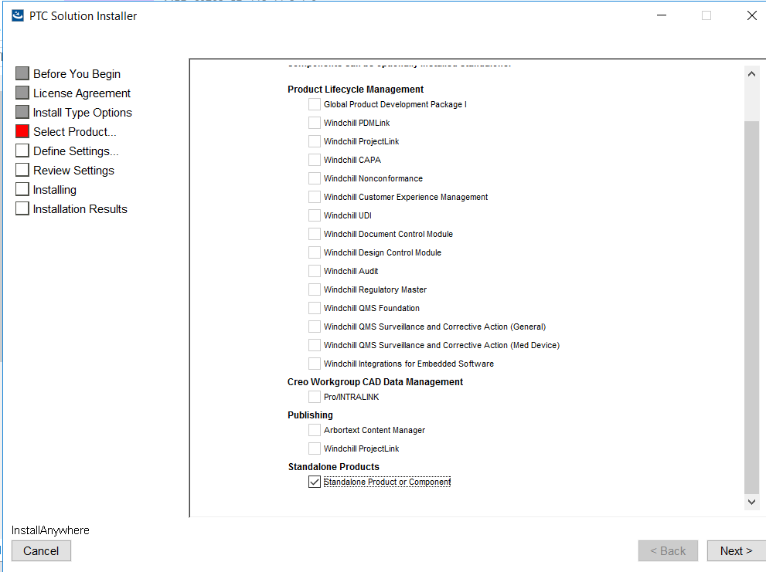

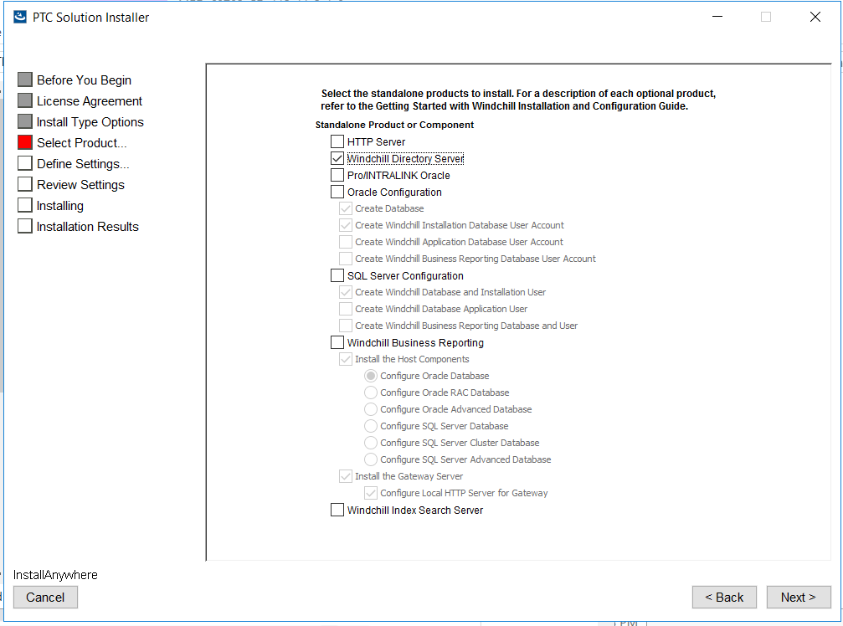

Select Windchill Directory Server

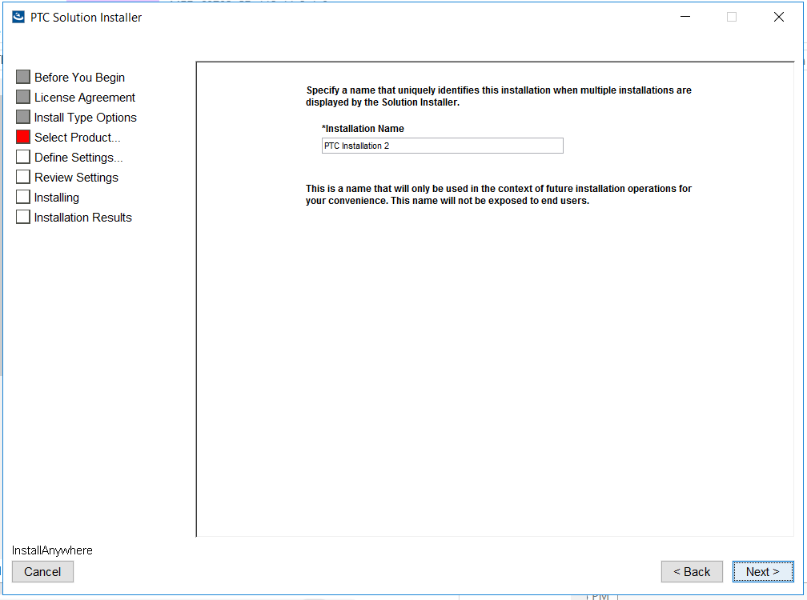

Set PTC Installation 2

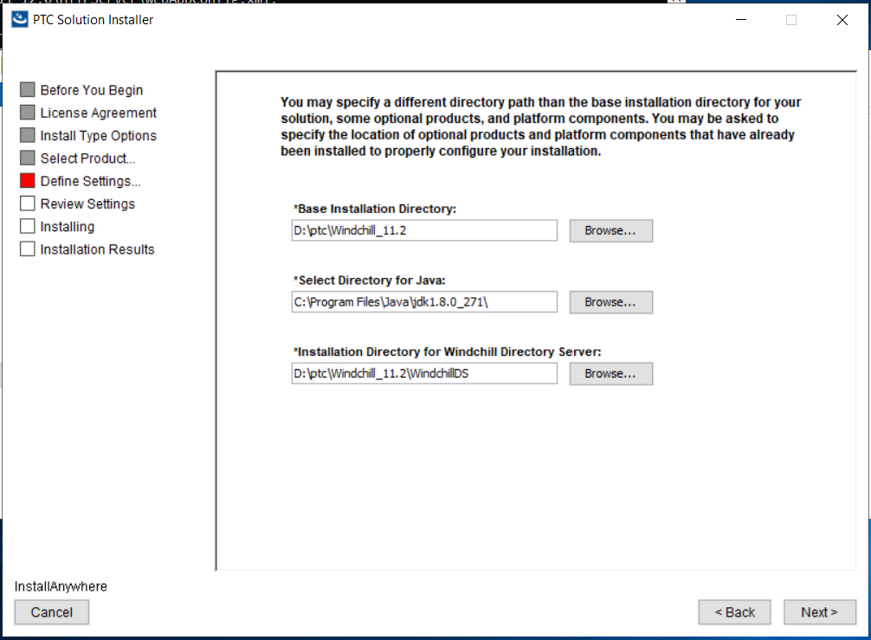

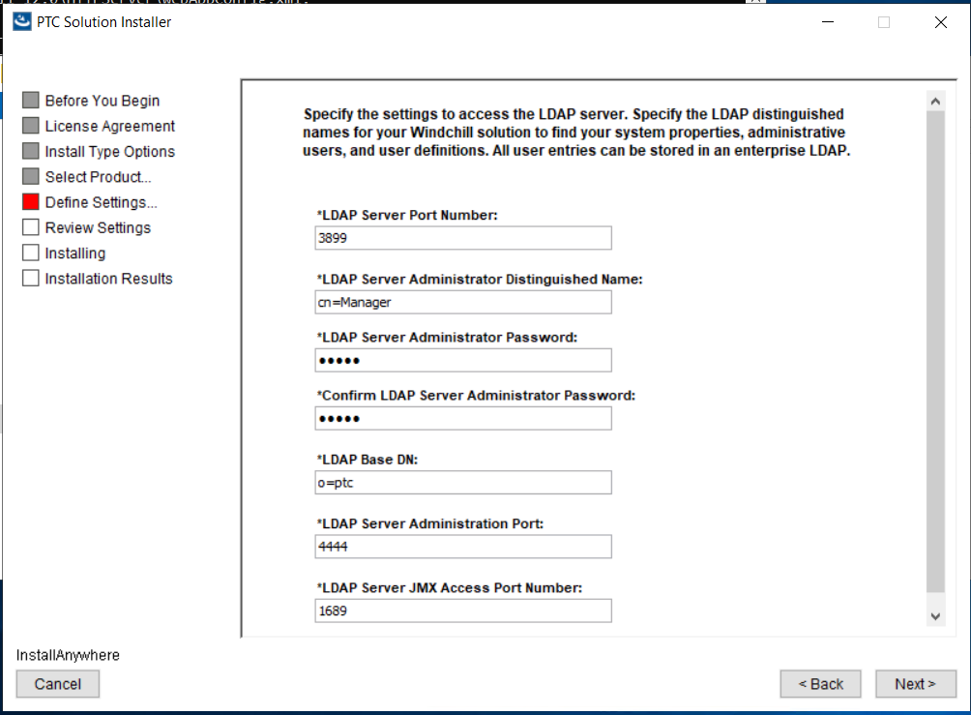

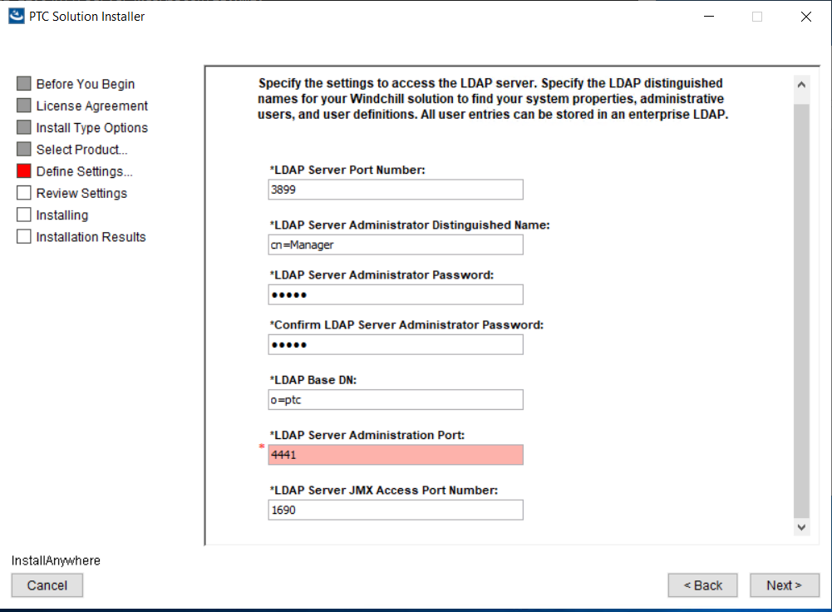

As OpenDJ is installed with 389 & 4440 port install WindchillDS as pointing to 3899 and 4441

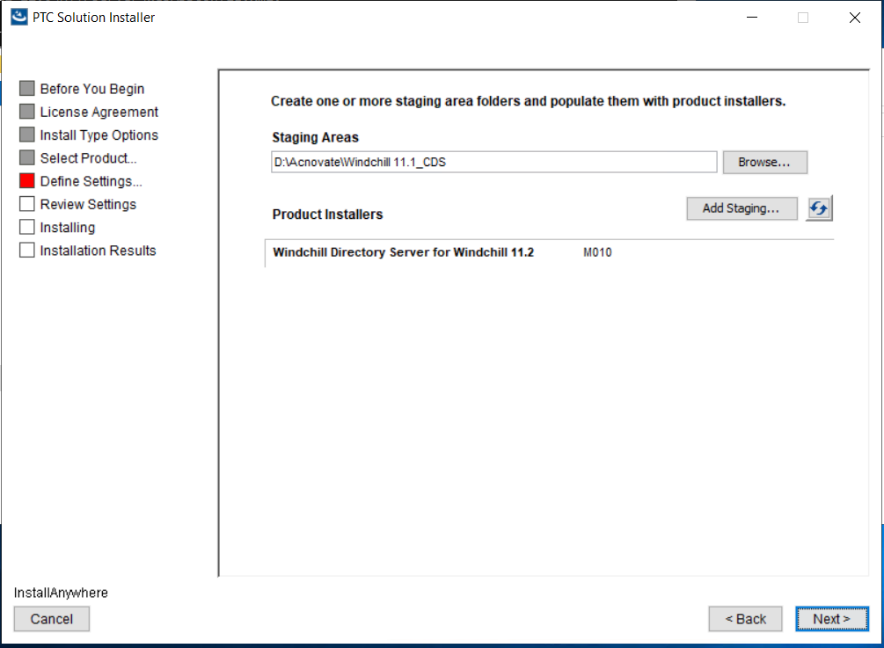

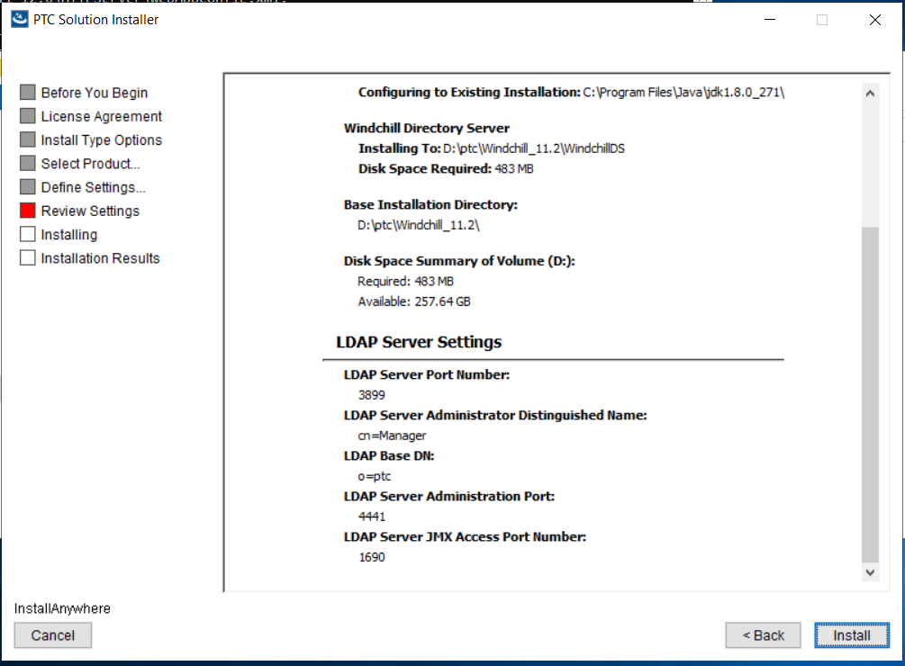

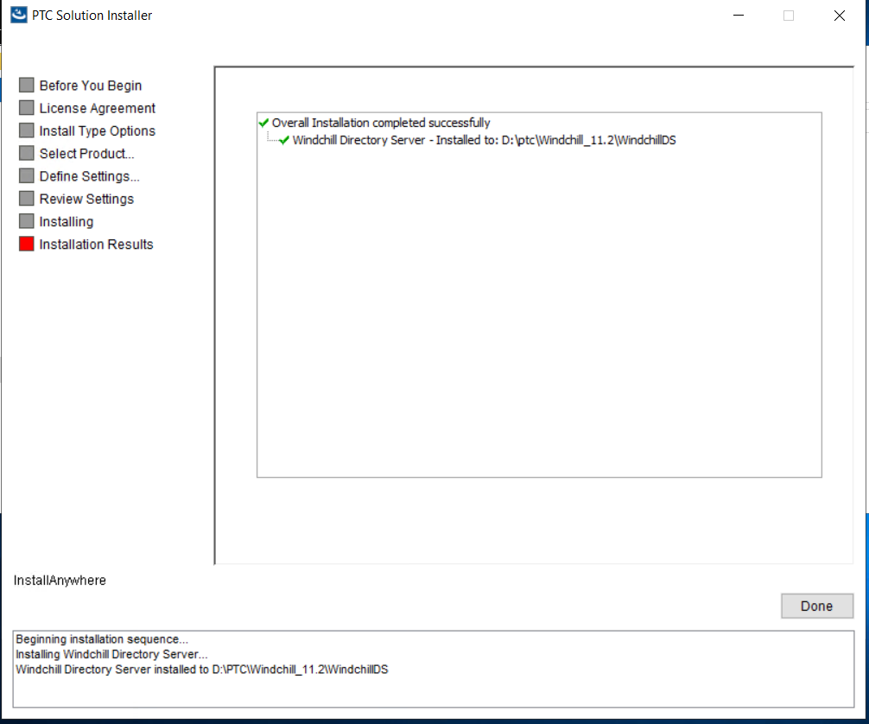

<https://www.ptc.com/en/support/article/cs337411>

setup LAX_VM "C:\Program Files\Java\jdk1.8.0_271\bin\java.exe"

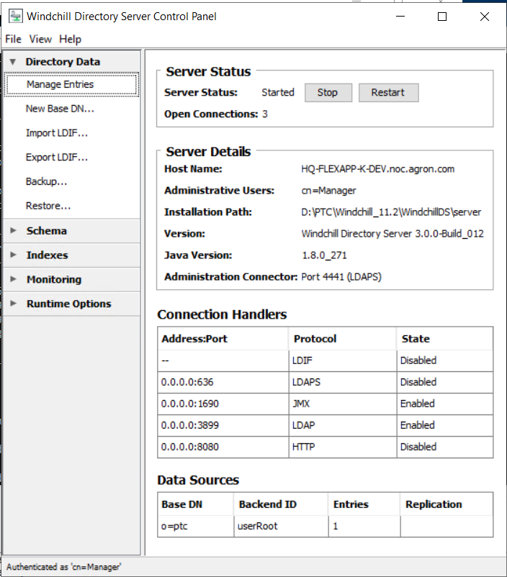

## Windchill Installation

Open setup from CDs directory D:\Acnovate\CDS\MED-60702-CD-120_12-0-2-0

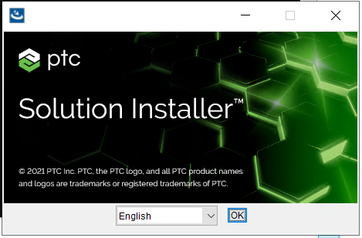

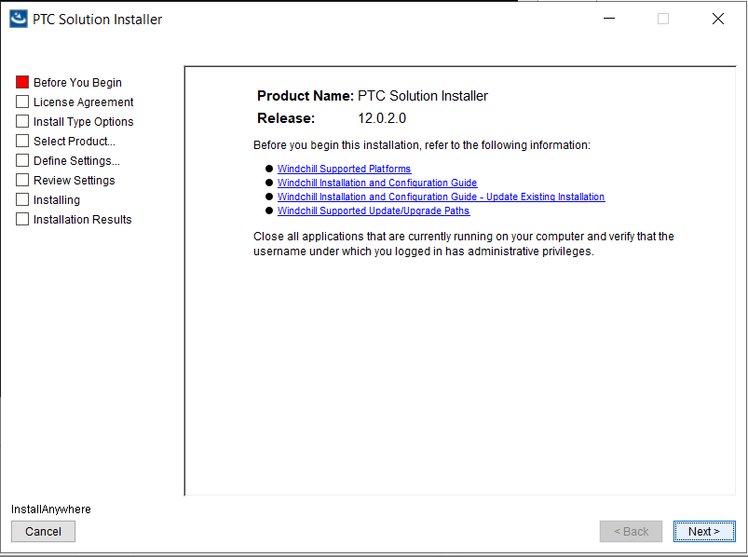

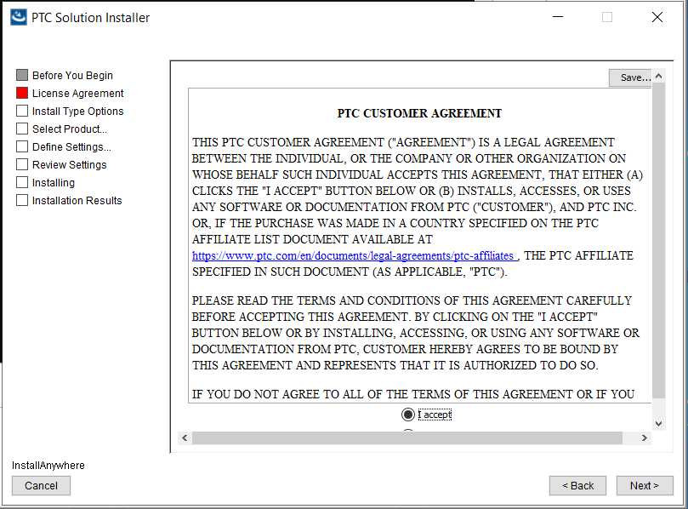

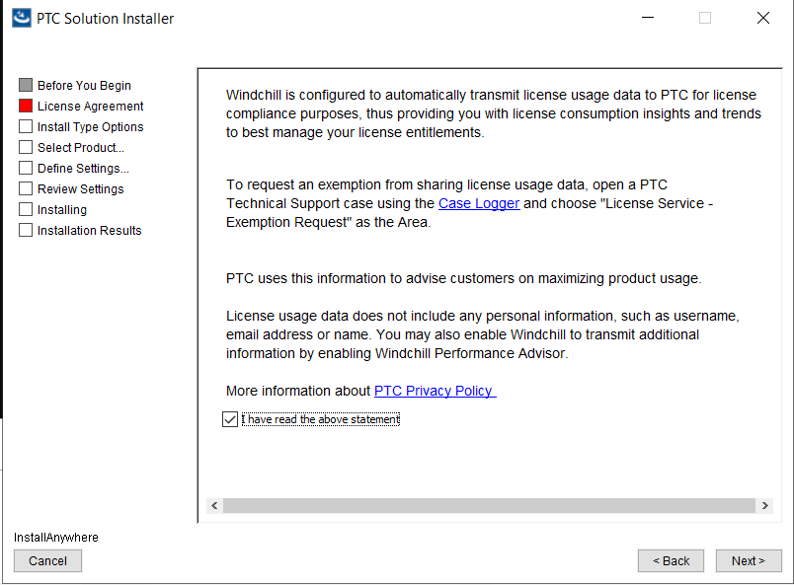

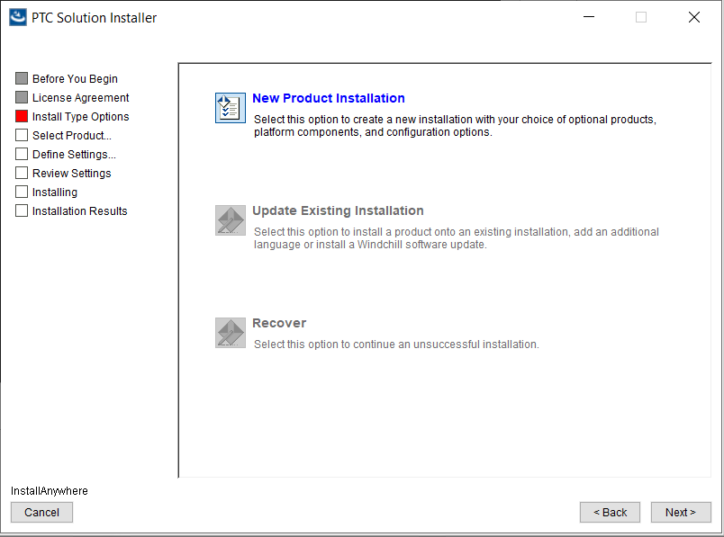

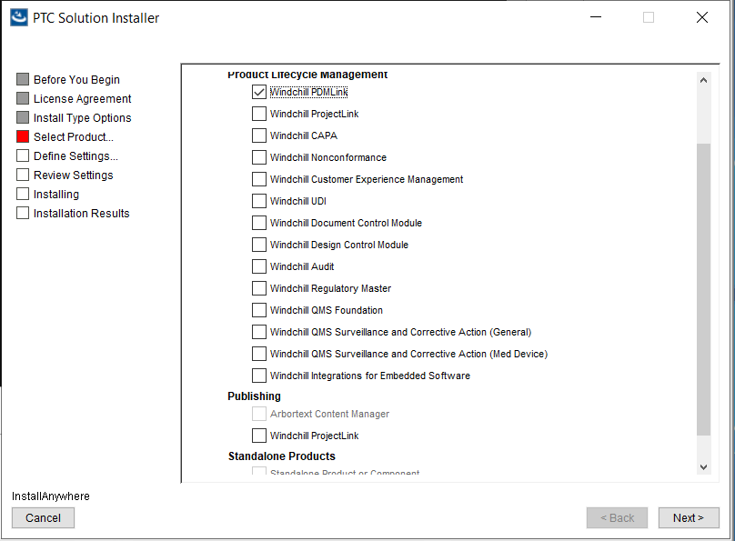

Select only Windchill PDMLink

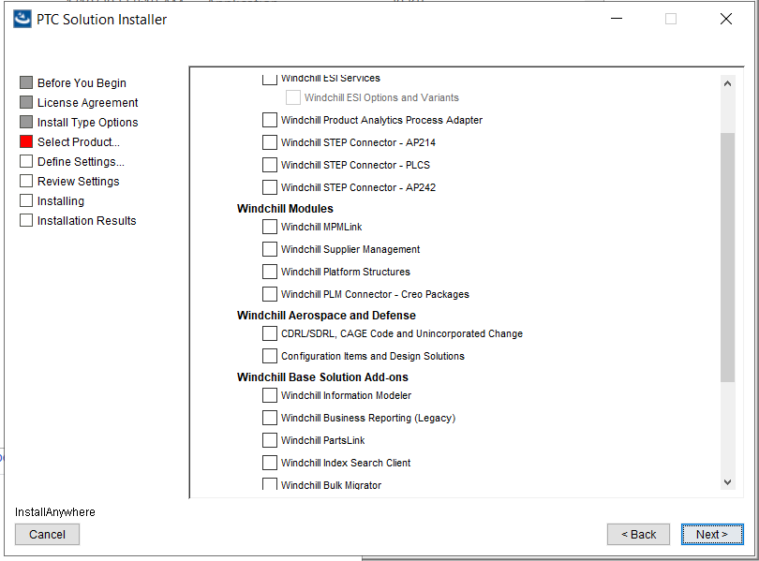

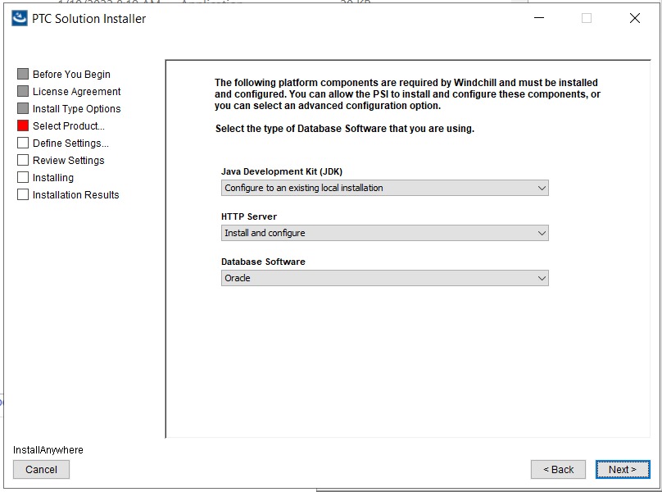

As Java 11.0.11 is already installed in D:\PTC\Java

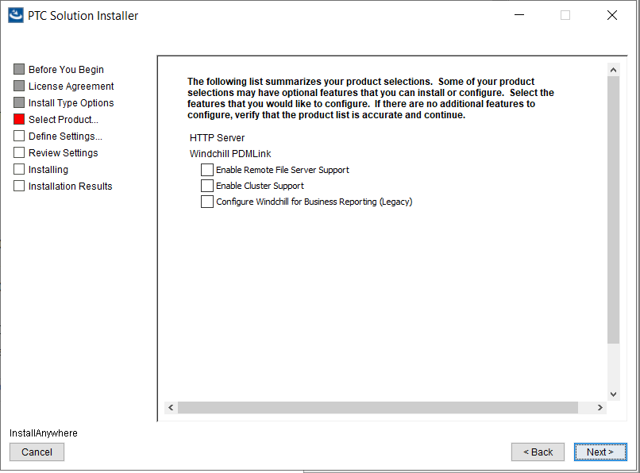

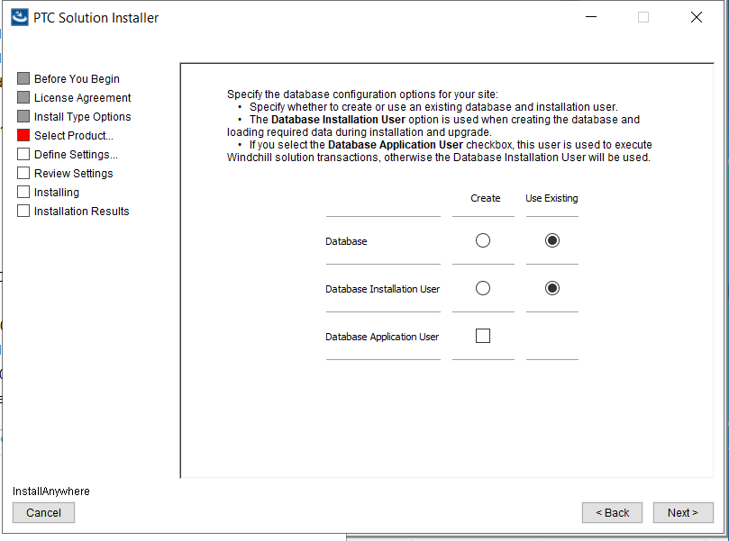

As Database is already created select use existing

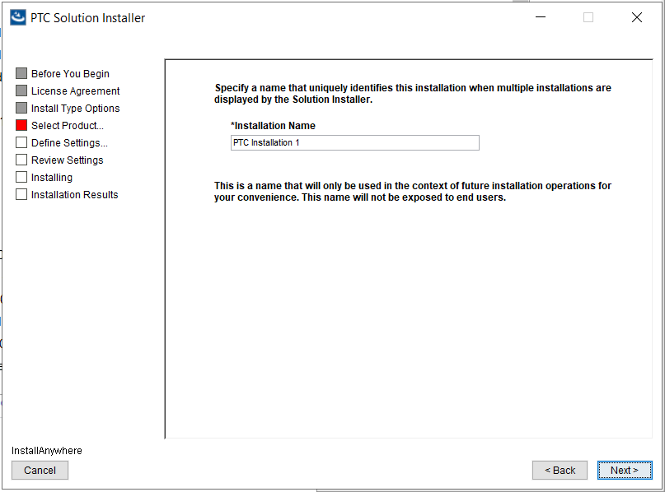

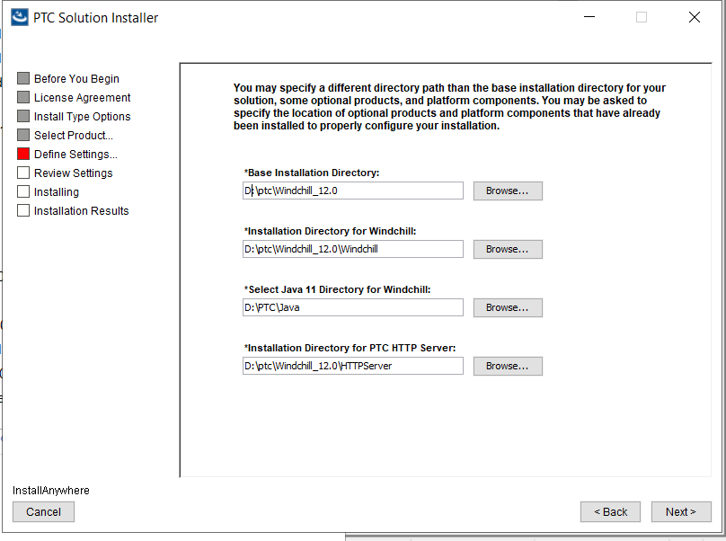

Select base installation directory D:\ptc\Windchill_12.0

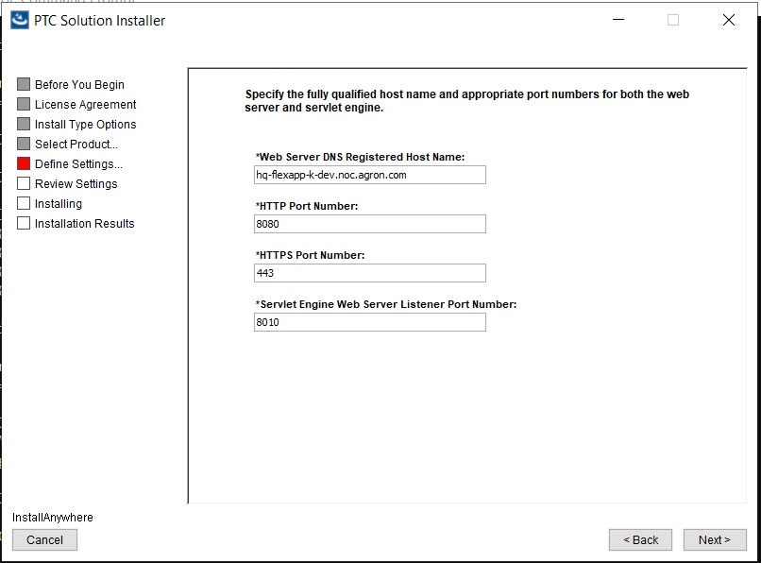

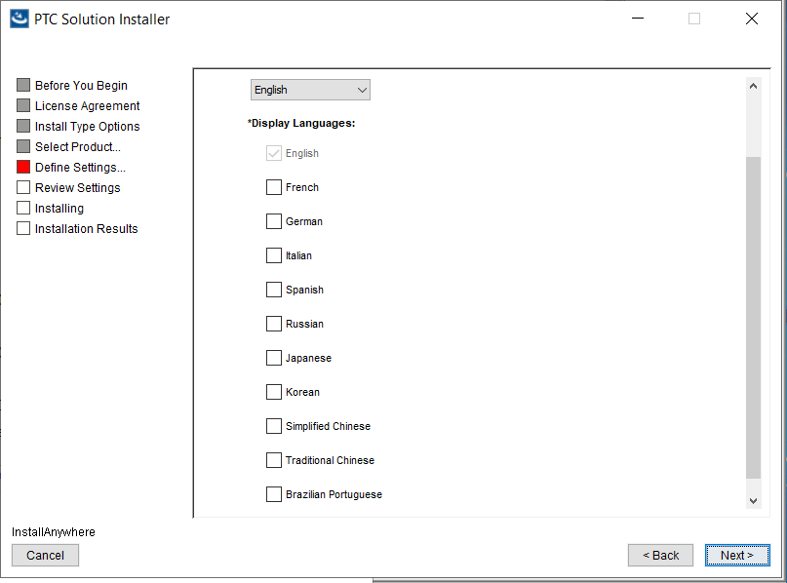

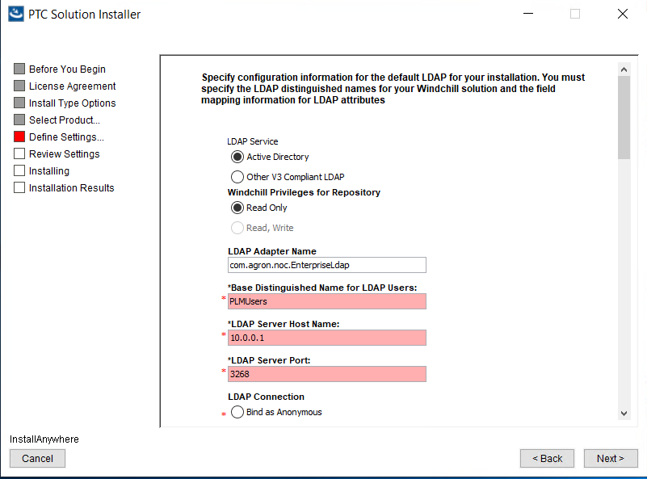

Cant use AD in our case

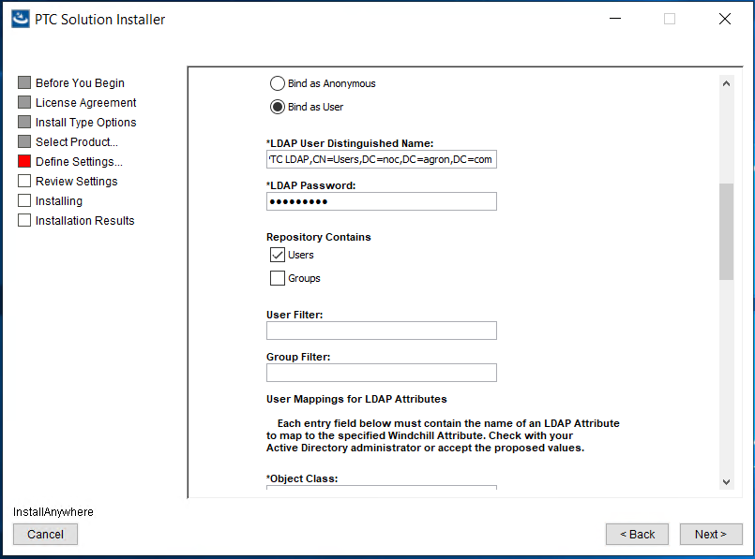

Cant use AD in our case

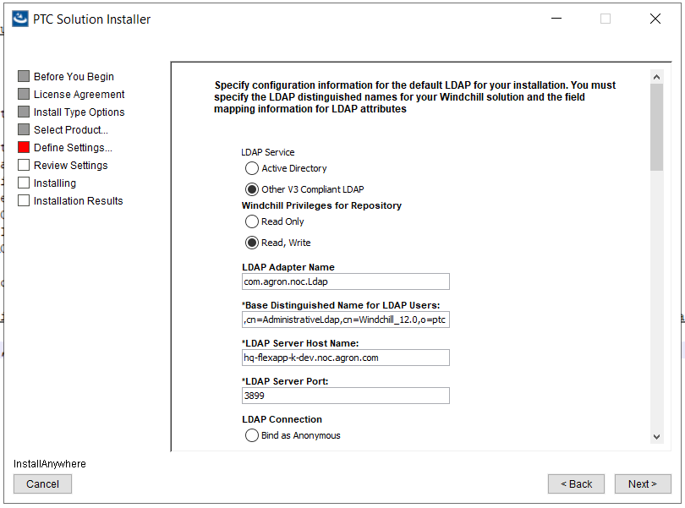

Follow the PTC solution for this step (Expectation is WindchillDS 11.2)<https://www.ptc.com/en/support/article/cs337415>

* Do not define the Base DN (e.g. o=ptc) as the Base Distinguished Name for LDAP Users

Use a different DN, e.g. ou=people,cn=AdministrativeLdap,cn=Windchill_12.0,o=ptc

And select local WindchillDS values

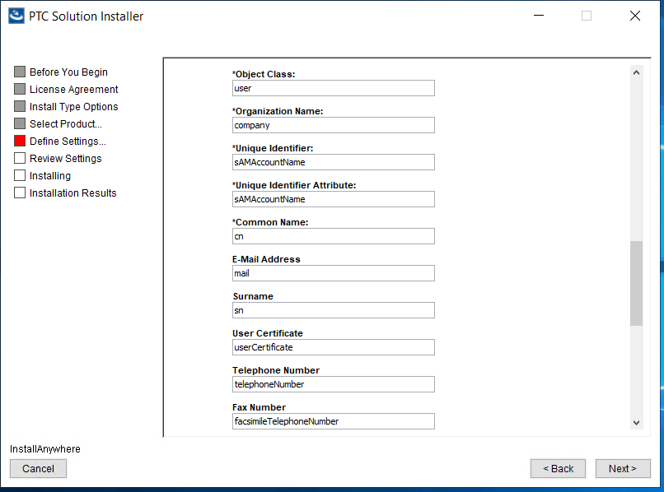

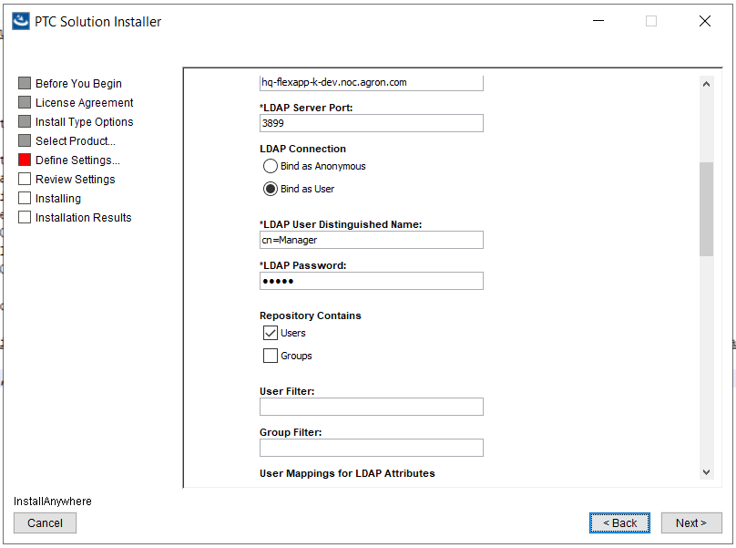

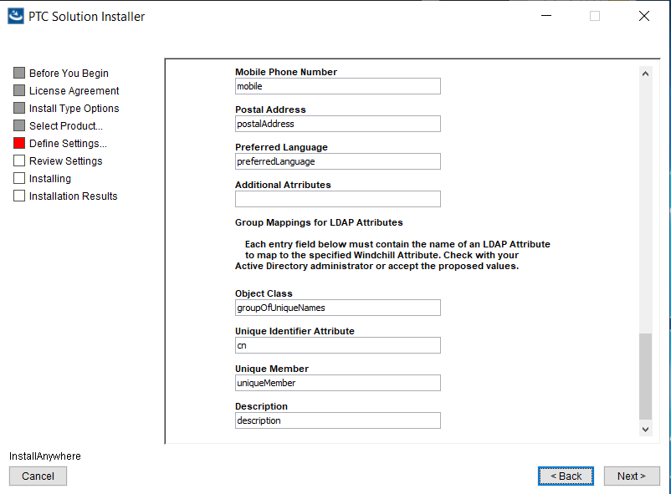

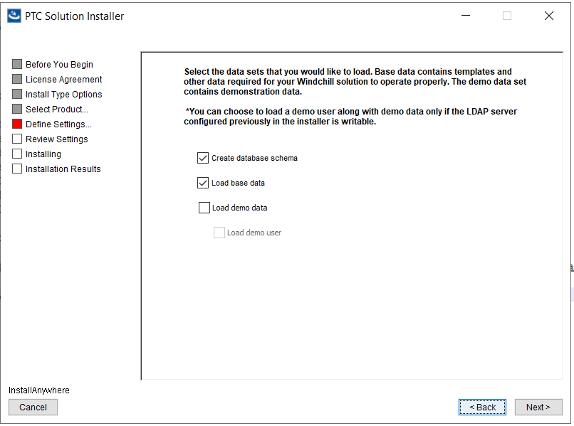

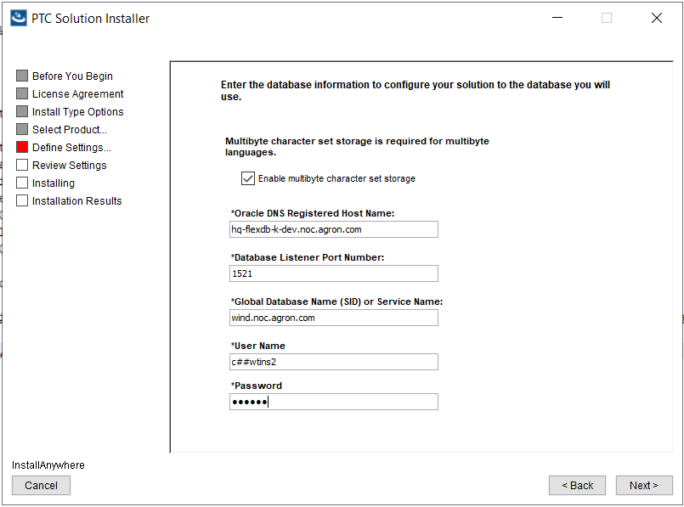

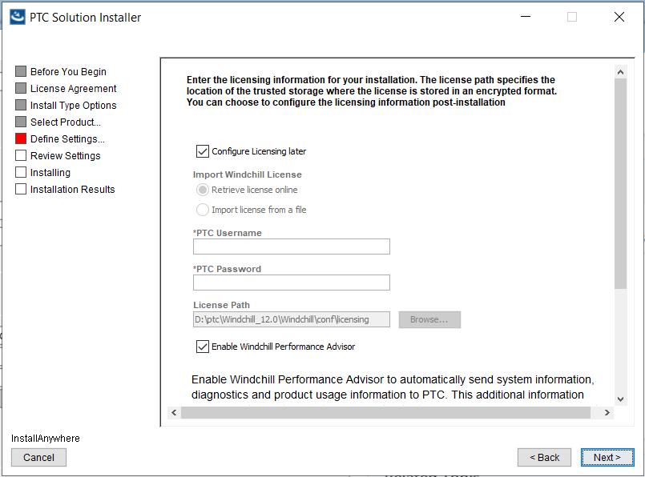

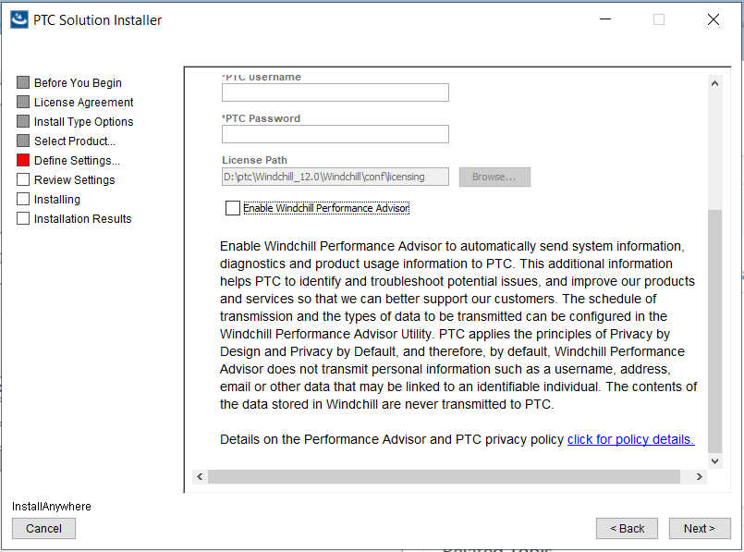

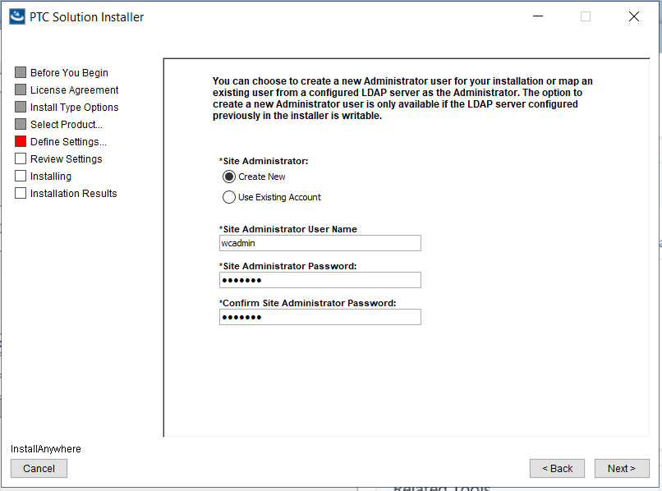

Hq-flexqawc

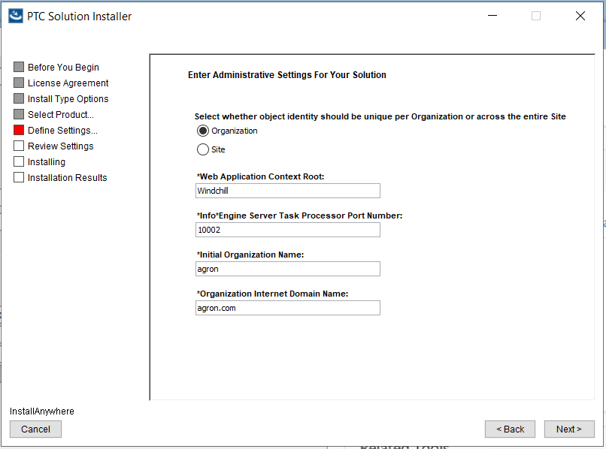

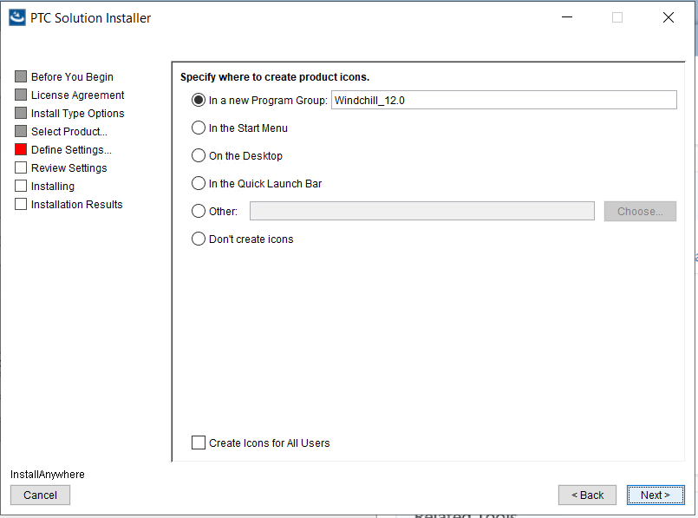

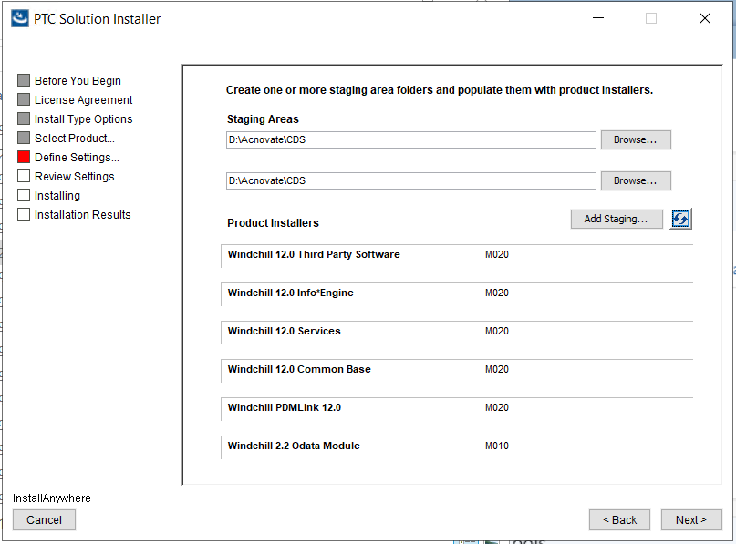

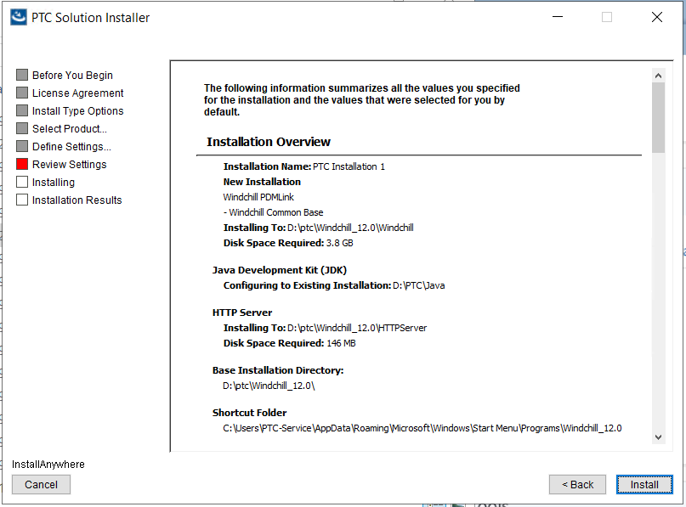

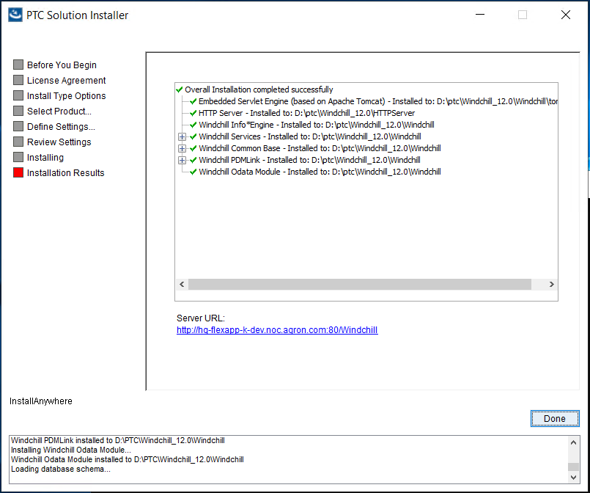

## Apache Changes

1. Create a file called workers.properties.additions in HTTPServer\conf
2. Add the line worker.ajpWorker.lb_retries=9 to this file
3. Regenerate the worker.properties by running

|  |
| --- |
| ant -f config.xml configureAJPWorkers  ant -f config.xml installService–DserviceName=”Apache2.4”  httpd –k stop/Kill the running httpd by closing the command window  Then ran  httpd –k start |

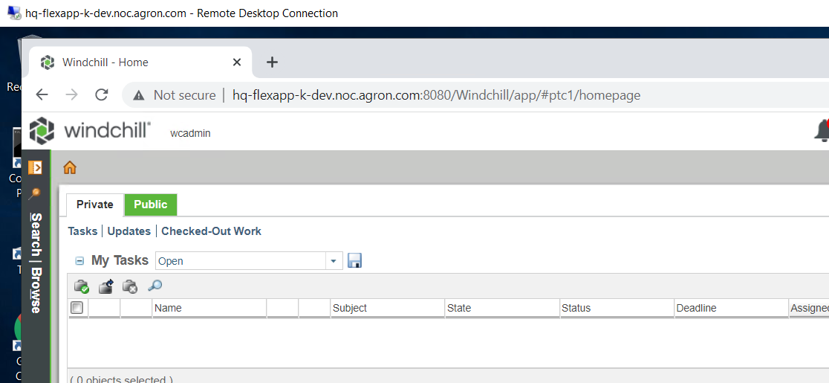

## Installing CPS

Stop Windchill services and download CPS CDs. Take a complete baclup of D:\PTC folder.

From CD folder

D:\Acnovate\CDS\MED-61006-CD-120_12-0-2-3_12-0-2-3-Bundle

From sub-folder ptc_solution_installer_12.0.2.3 ran setup.bat

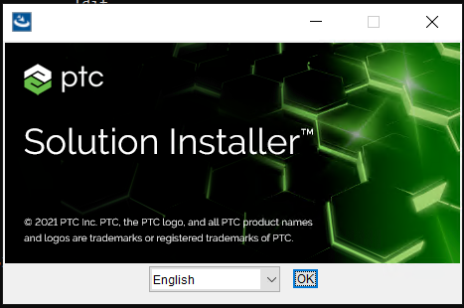

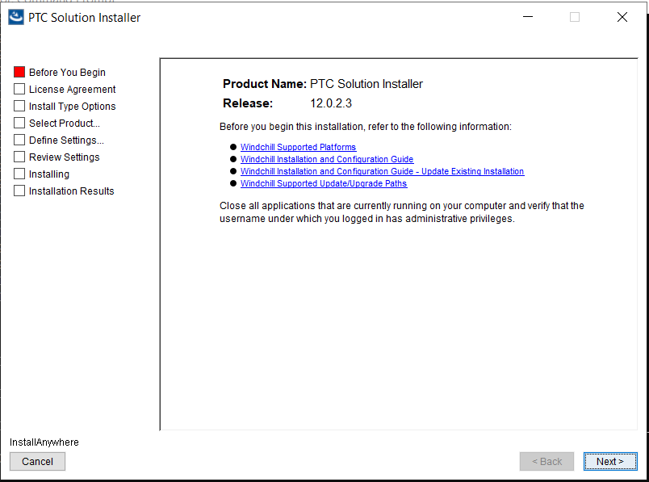

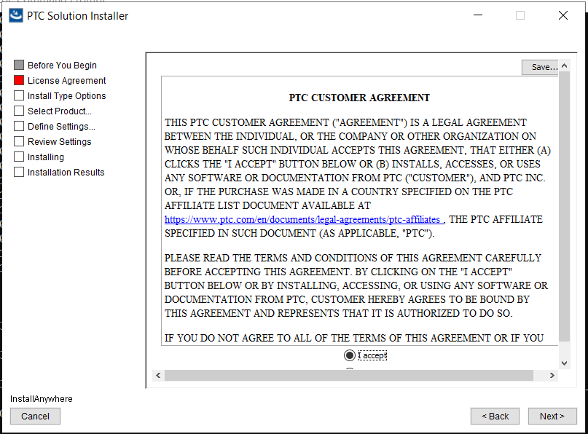

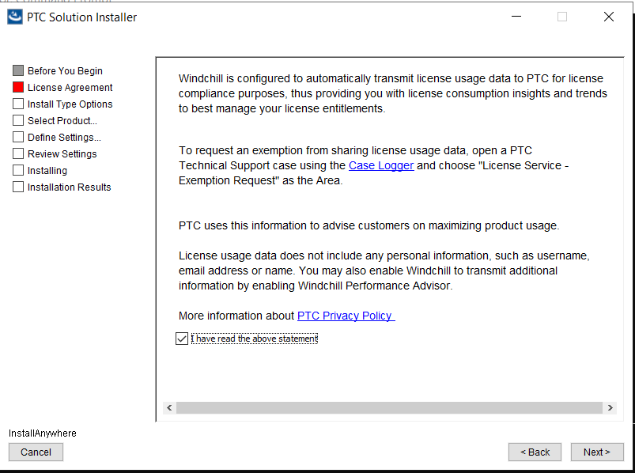

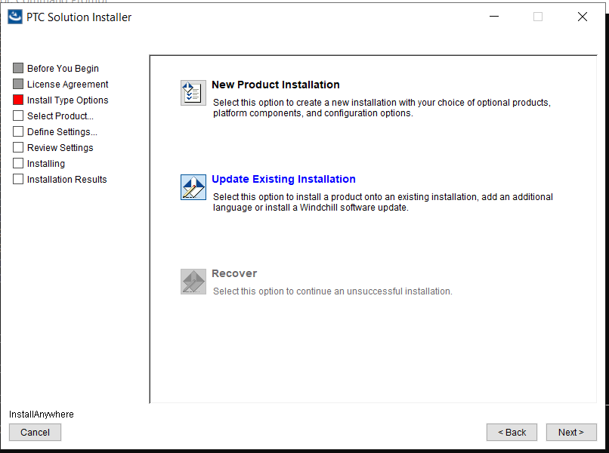

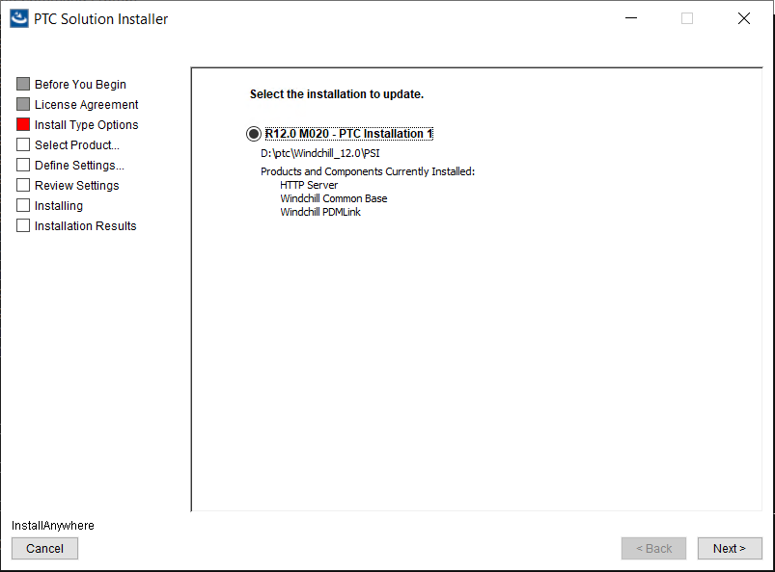

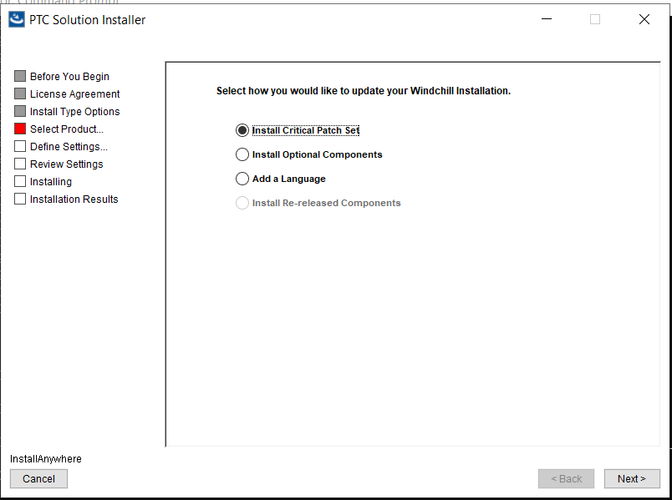

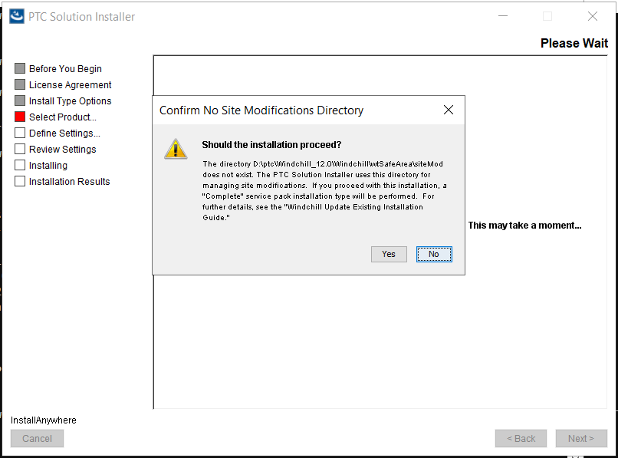

Click Yes to proceed

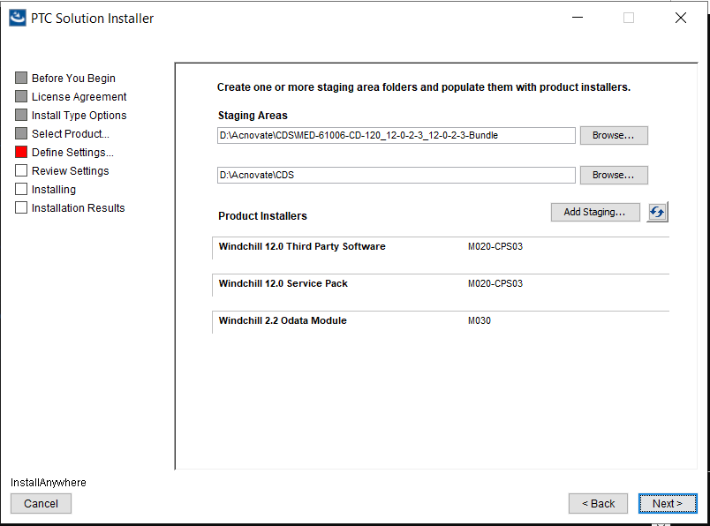

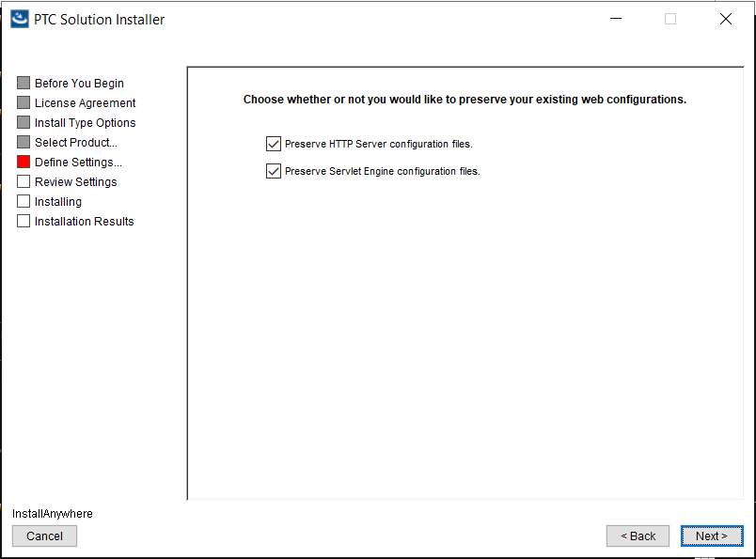

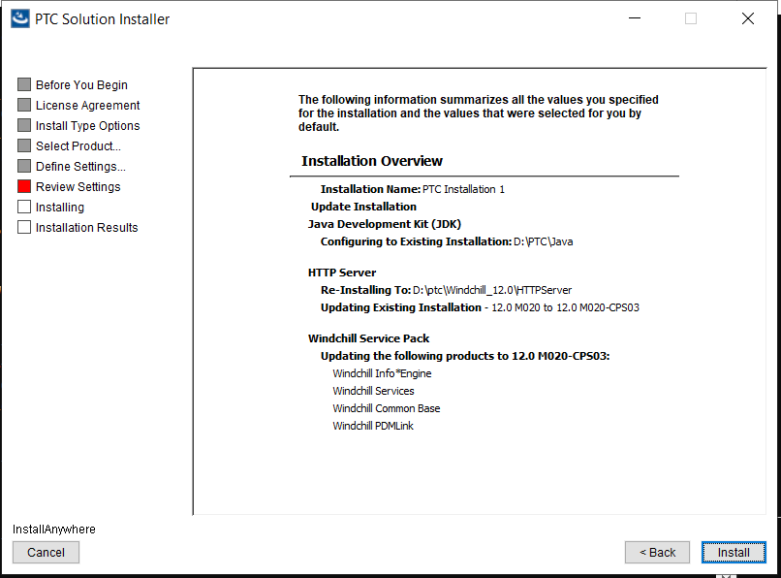

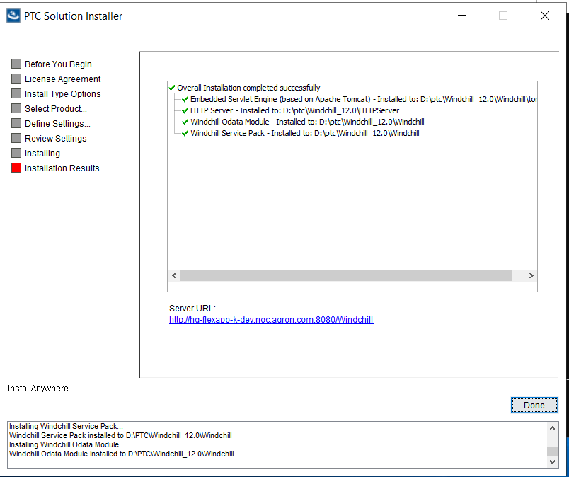

## FlexPLM Installation

1. Once installation of CPS is complete start and connect as wcadmin to Windchill
2. If everything is working fine, then proceed
3. From Site-> Lifecycle Template Administration
4. Right click in Default Life cycle Templates and click on Edit
5. For each Phase (In Work, Under Review & Released) go to Phase properties
6. Click on Workflow tab and click clear on the Phase process and Gate process

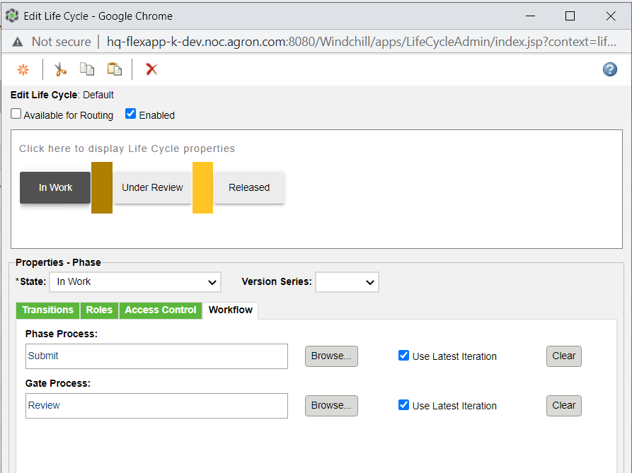

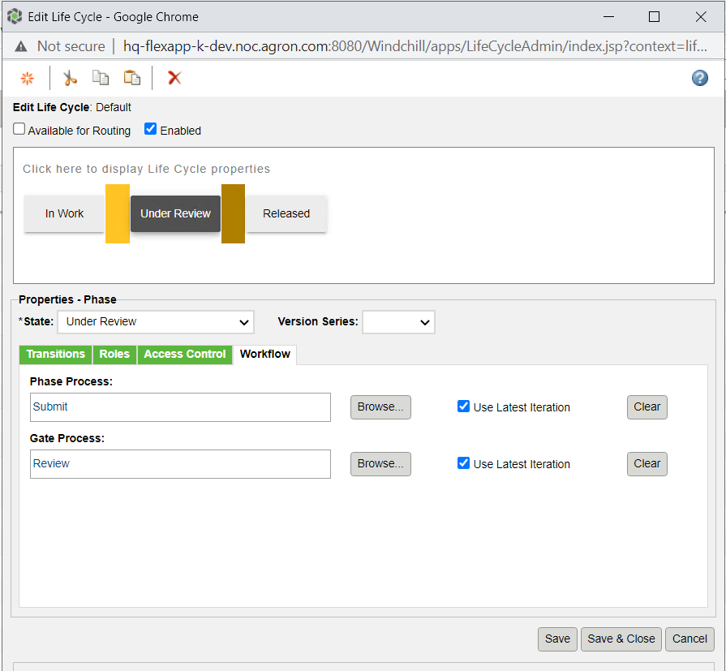

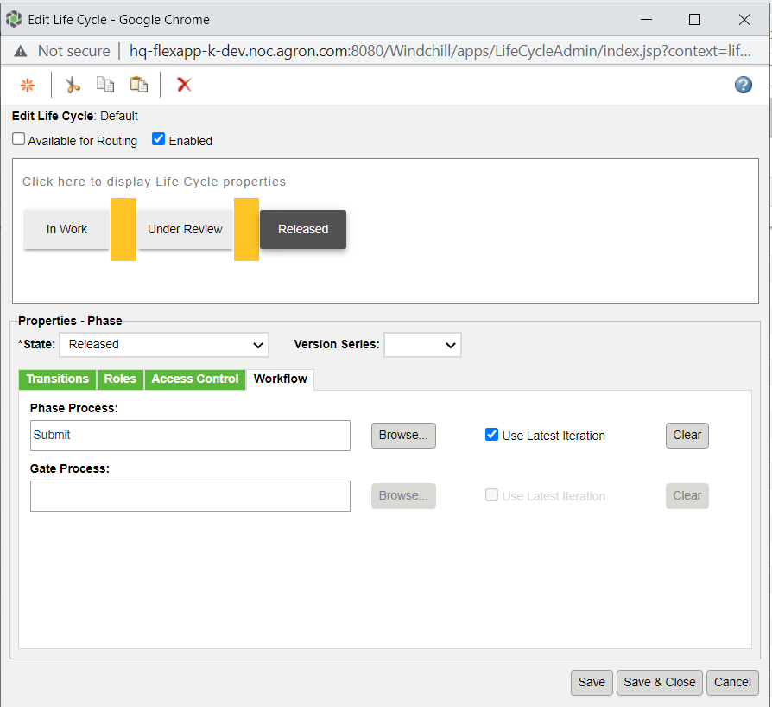

Stop Windchill services

Go to D:\Acnovate\CDS\MED-60496-CD-120_12-0-3-0

Extract FlexPLM.12.0.3.0.172.zip to D:\PTC\Windchill_12.0\Windchill

Choose Overwrite option continue and once done go to

D:\PTC\Windchill_12.0\Windchill\src\com\lcs\build\installer\install.bat

Follow the install option

Prior make sure wcadmin password has no special characters as $,-etc in it.

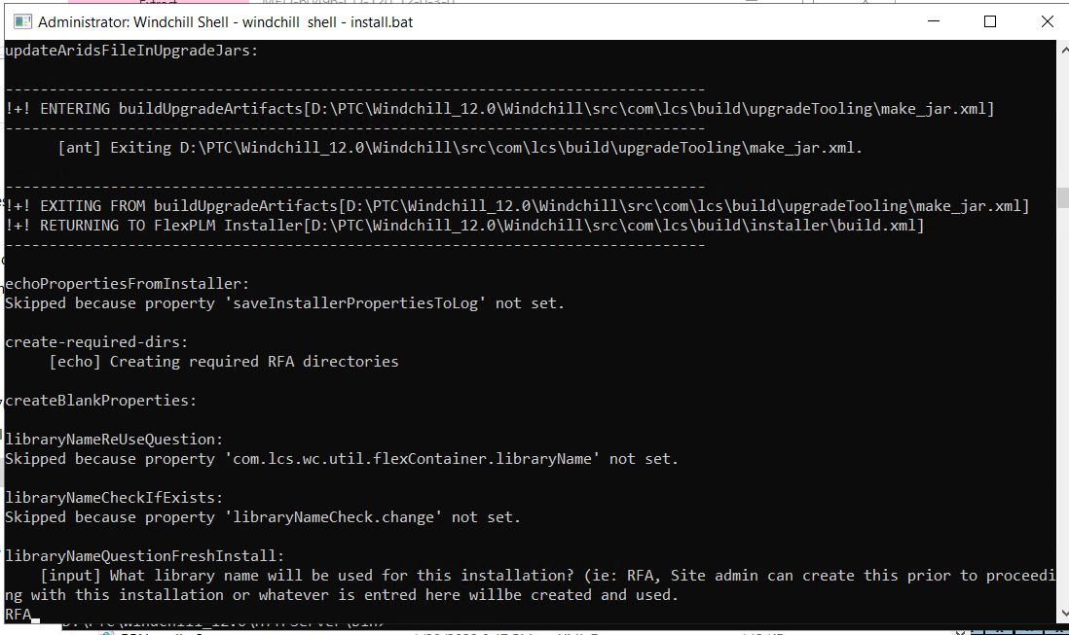

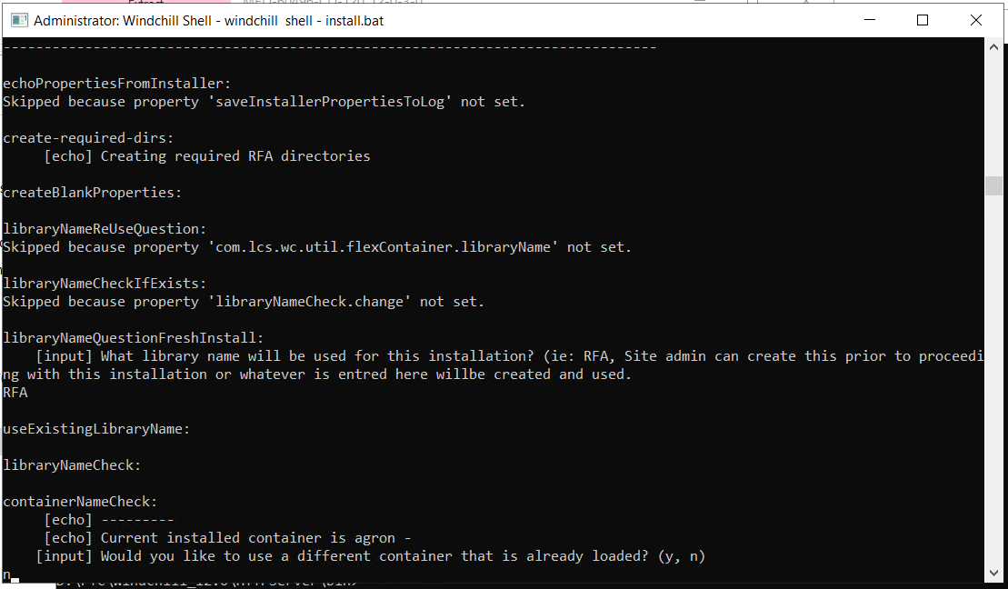

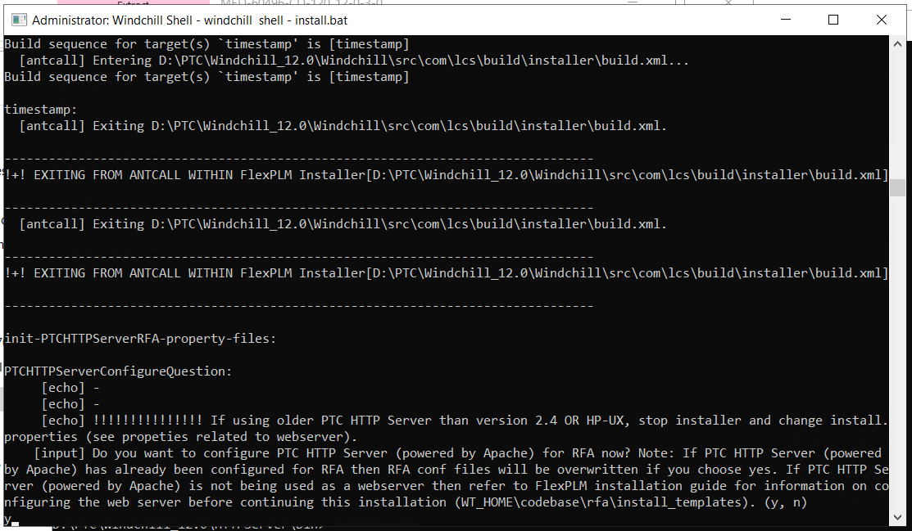

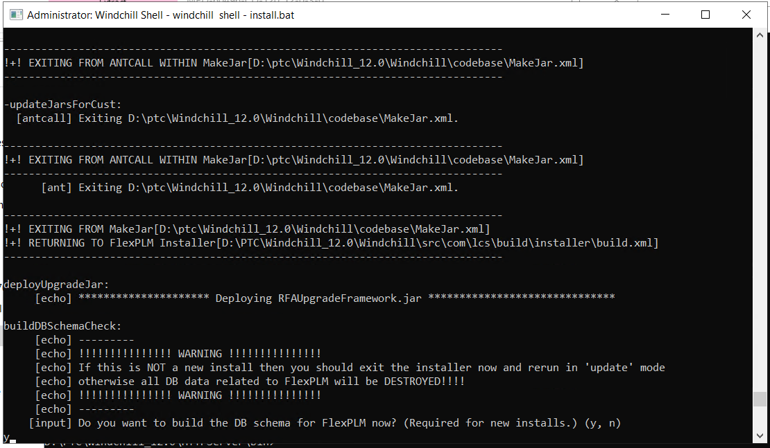

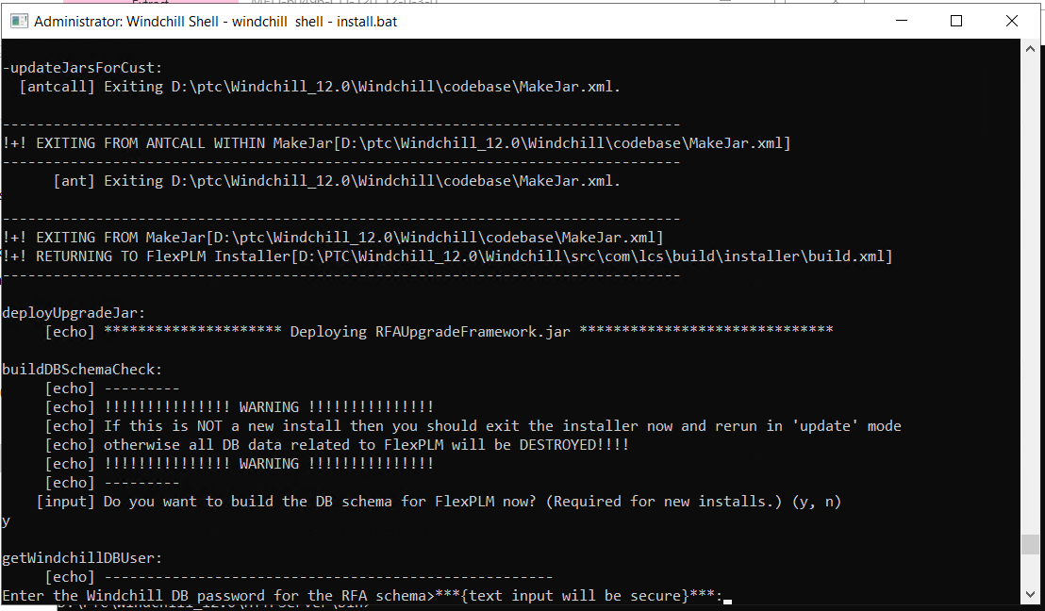

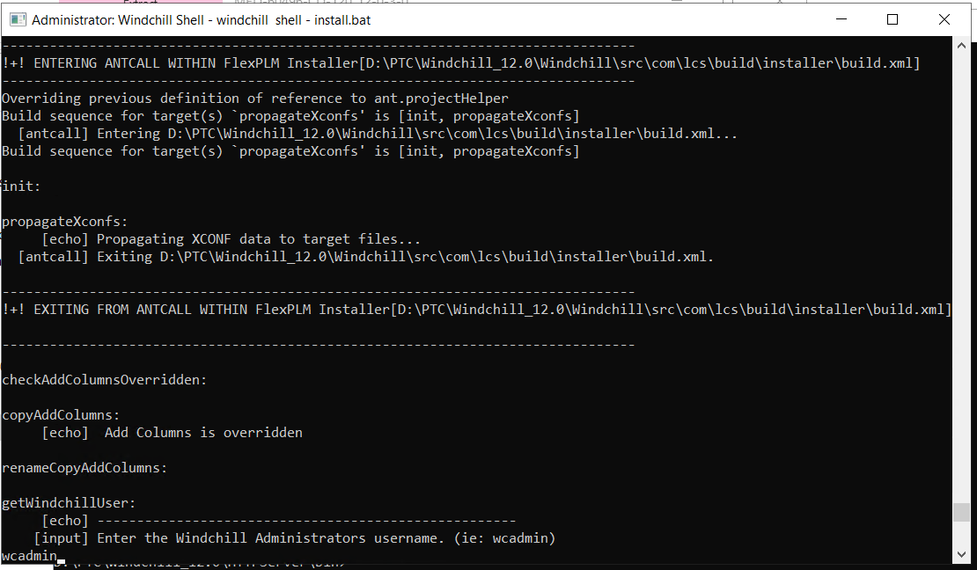

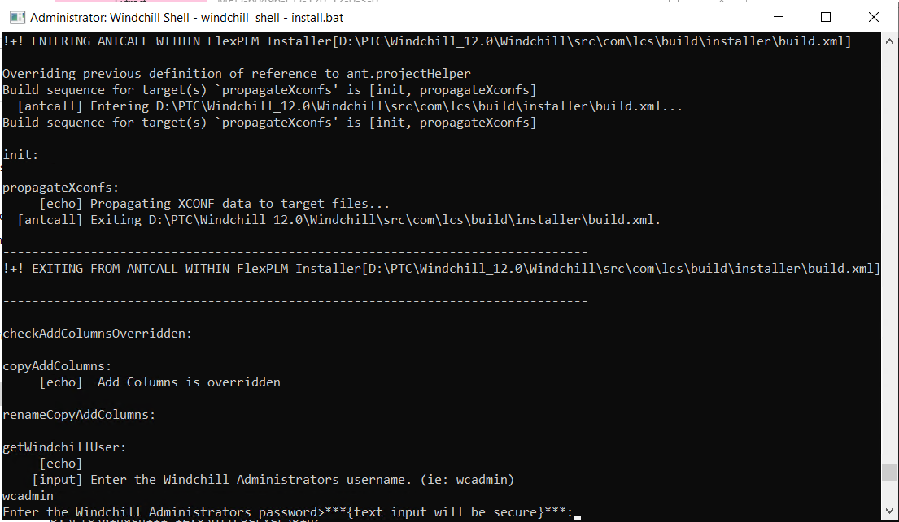

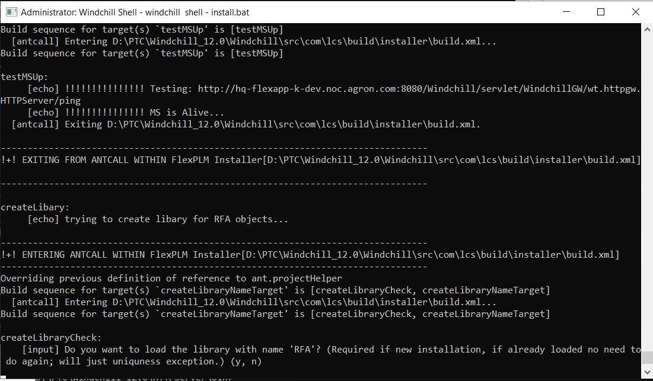

## Changes for Tomcat

Avoid these entries in the Methodserver please disable classpath scanning by adding below line to **Windchill\tomcat\conf\context.xml**:

<JarScannerscanClassPath="false"scanAllFiles="false"scanAllDirectories="false"/>

Create folder, **<Windchill>/TPAAHC**

## Changes for Log entries

<https://www.ptc.com/en/support/article/cs282233>

in WINDCHILL_HOME\codebase\web-inf\log4jMethodServer.properties

add the below lines at end of the filelogger.AttributeDefinitionViewFactory.name=com.ptc.core.lwc.server.cache.factory.AttributeDefinitionViewFactory

logger.AttributeDefinitionViewFactory.level=FATAL

License Download through online(Skip before Upgrade, as upgrade will overwrite the licenses and we are forced to do it again)

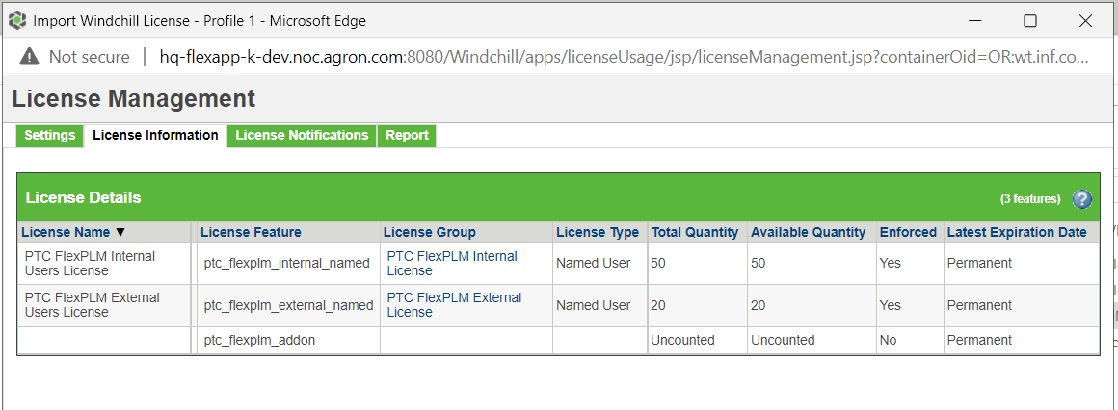

## Restart Services

1. From Windchill shell ran the following commands

Windchill stop

cd D:\ptc\Windchill_12.0\httpserver\bat

httpd -k stop(or from windows services stop **Apache 2.4**service)

1. From dos prompt ran the following commands

Cd D:\ptc\OpenDJ\bat

stop-ds (or from Windows services stop **OpenDJ server** service)

1. Cleanup tomcat/tasks cache

From Windchill shell go to

**WT_HOME\tomcat\instances**

Delete all the folder/files under the instances folder

Go to **WT_HOME\tasks\codebase\com\infoEngine** folder

Delete compiledTasks folder

1. Starting Windchill

From command prompt go to

cd D:\ptc\OpenDJ\bat type

start-ds (or from Windows services start**OpenDJ server** service)

1. From Windchill shell ran the following commands

Cd D:\ptc\Windchill_12.0\httpserver\bat

httpd -k start(or from windows services start**Apache 2.4** service)

windchill start

1. Wait for 10 minutes to test connecting the server.